Hostbridge HBJS Workshop III



In this workshop you will create a script and modify it to have the Mainframe’s CICS region to call an outside web service that will return weather reports.

**Configure:**

The first part will be setting up the Hostbridge extension which has already been installed for you.

Click on the HB.js icon.

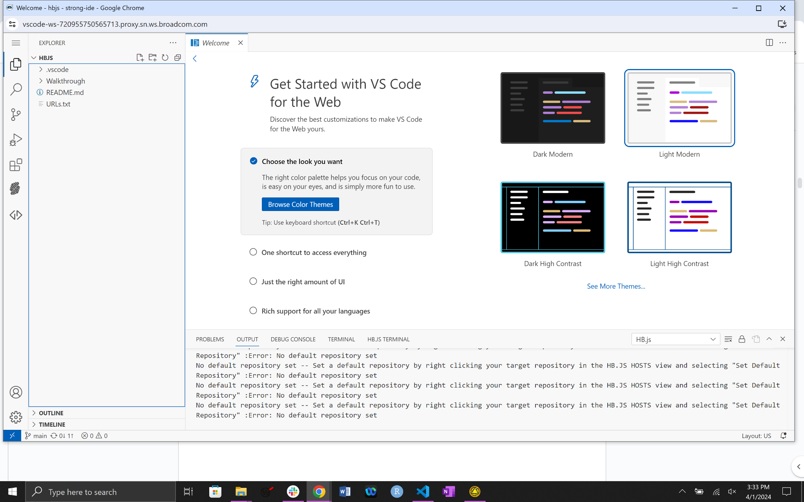

The following screen is returned.

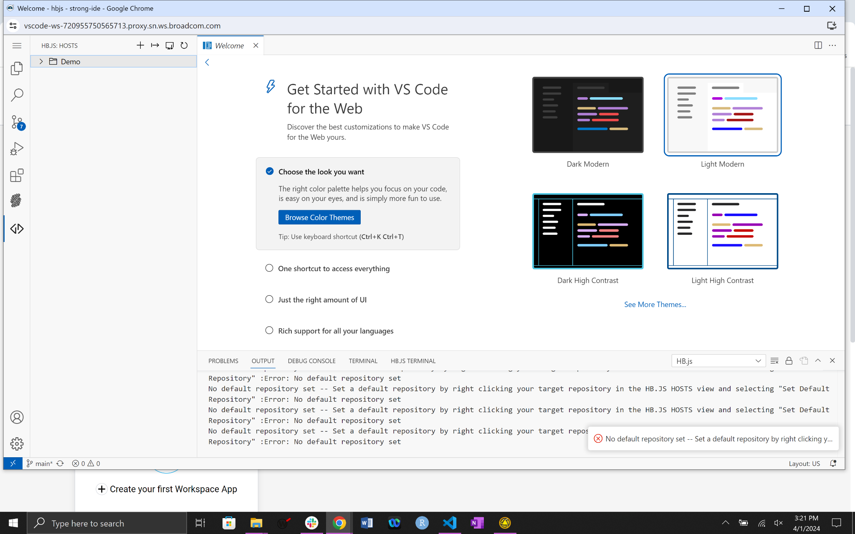

At this point we have already configured HB.JS to point to the mainframe and the CICS region. Right click on Demo > Edit Host so that we can add a default user ID. Afterwards, we will address the “No Default Repo… “ error.

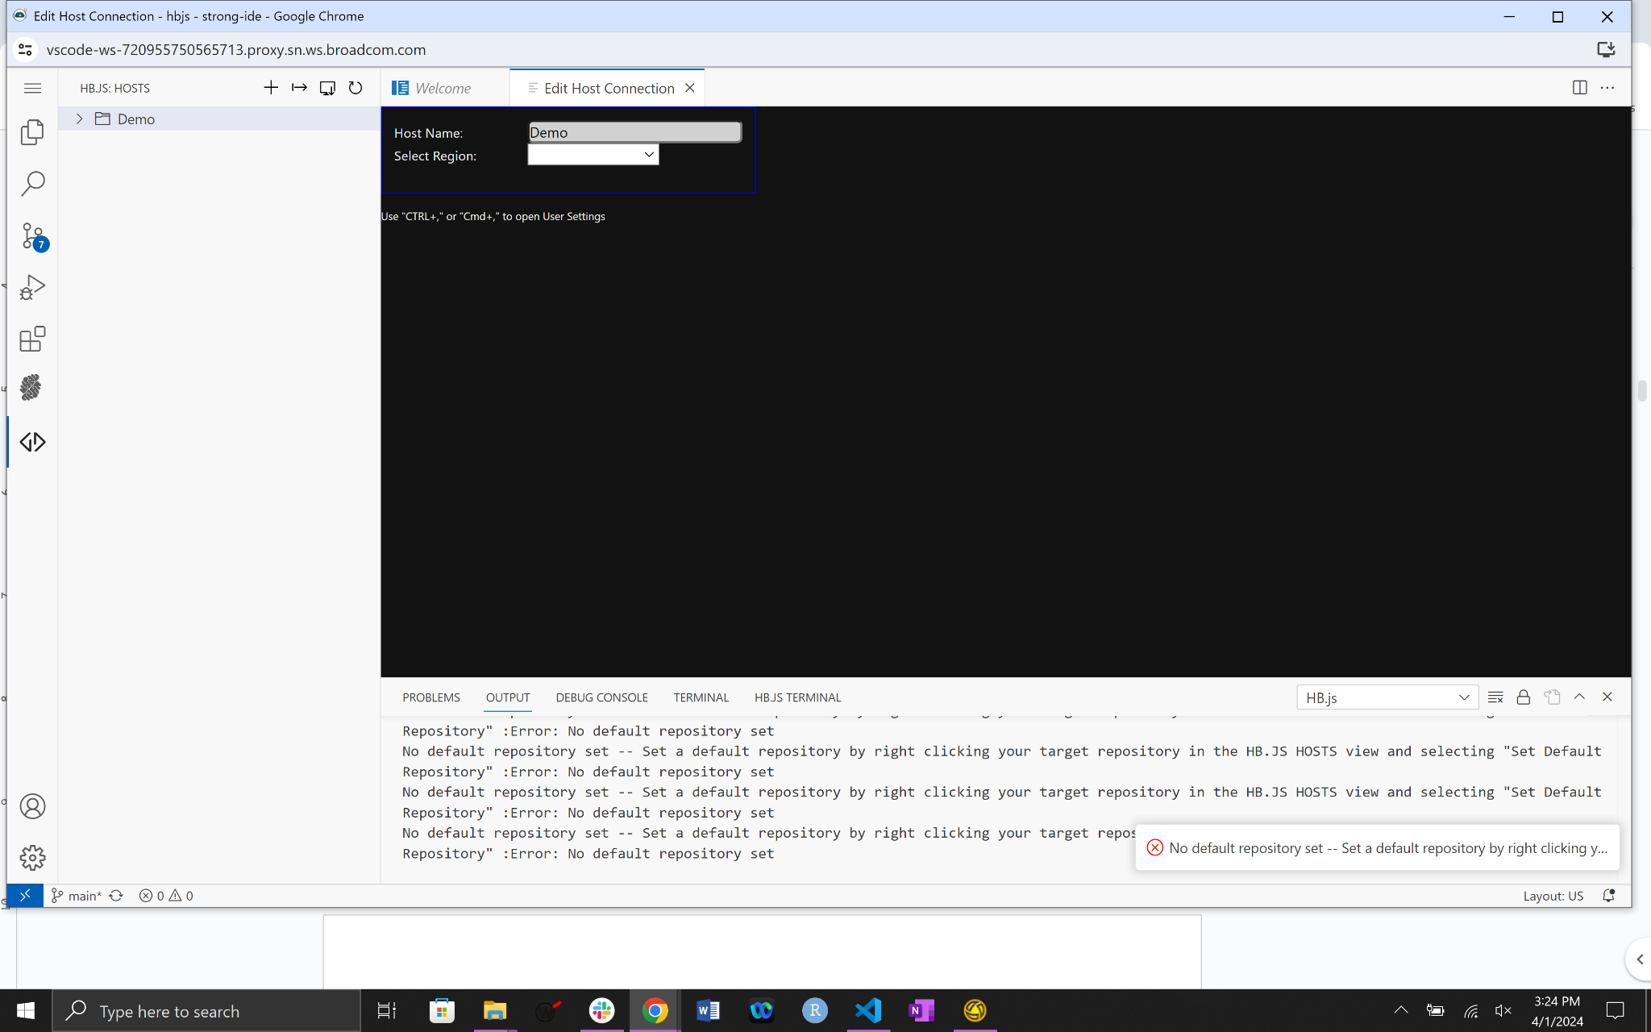

Select Training3 for the region.

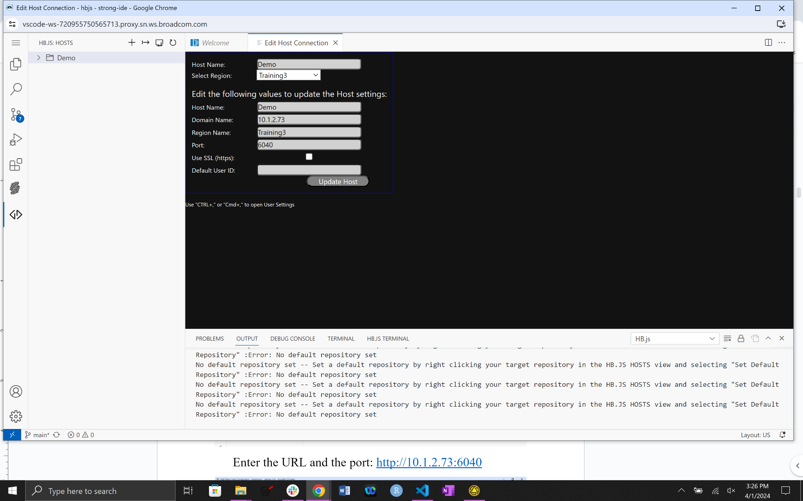

Enter CUST0## for the Default User ID and then click Update Host. Please replace ## with your assigned UserID number.

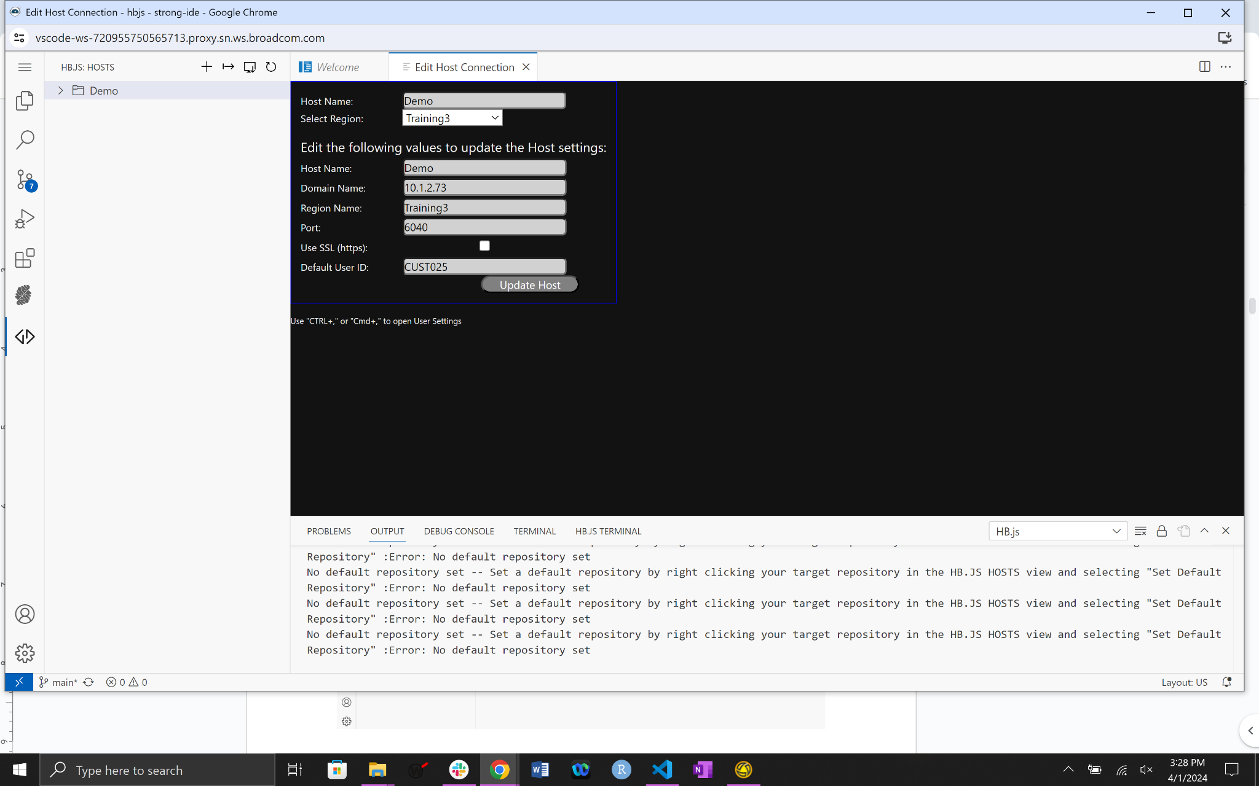

This will return the following screen. You should see the Host Updated Successfully message on the bottom right.

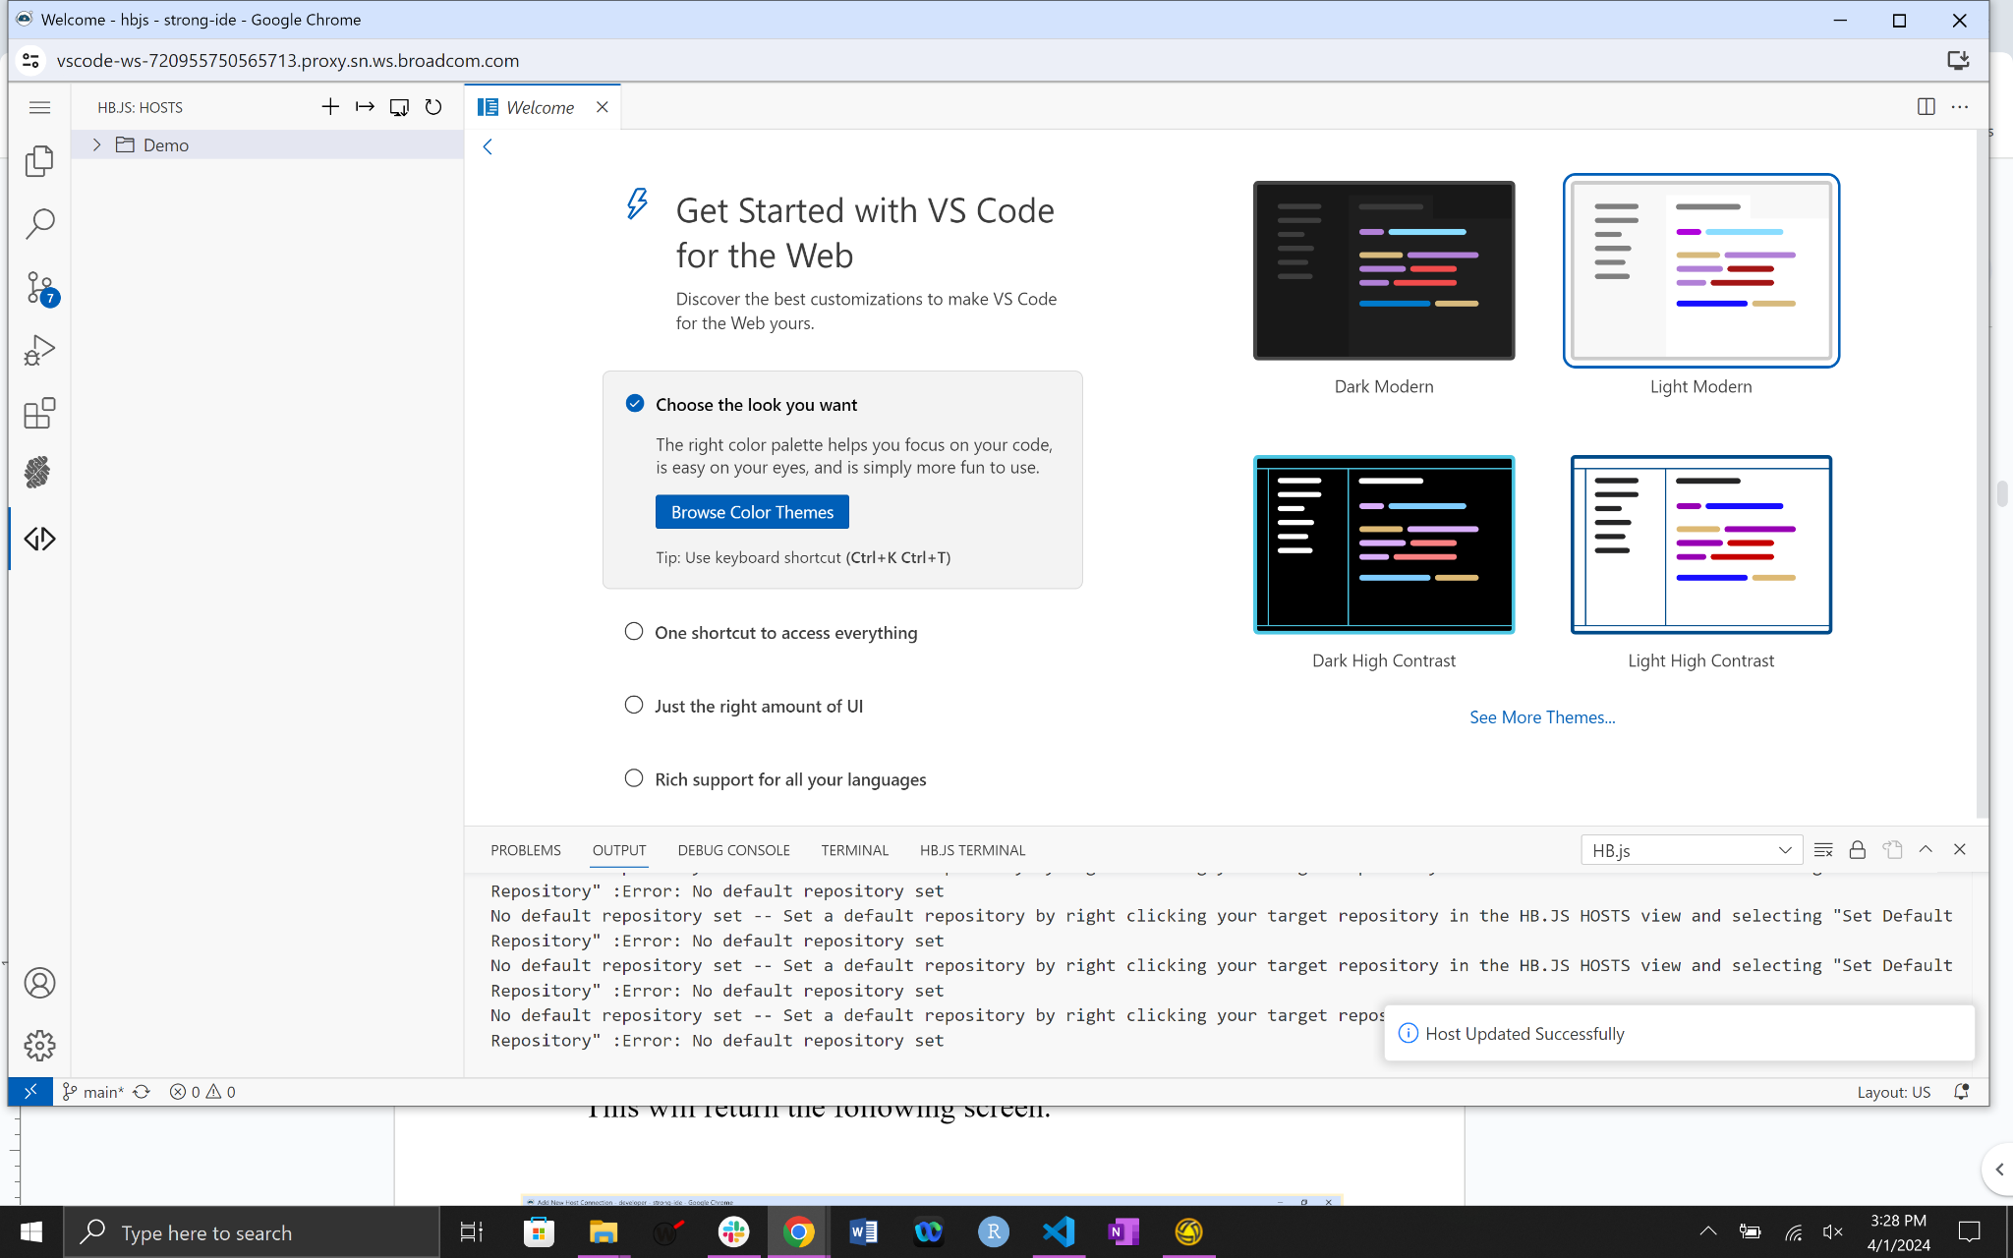

Now to deal with the error, “No default repository set …”.

Expand the DEMO and TRAINING3 folders causing a pop-up box to appear. Here is where you enter your mainframe password CUST0##, where the ## is the number assigned to the workshop user. Press enter.

The following screen will be returned.

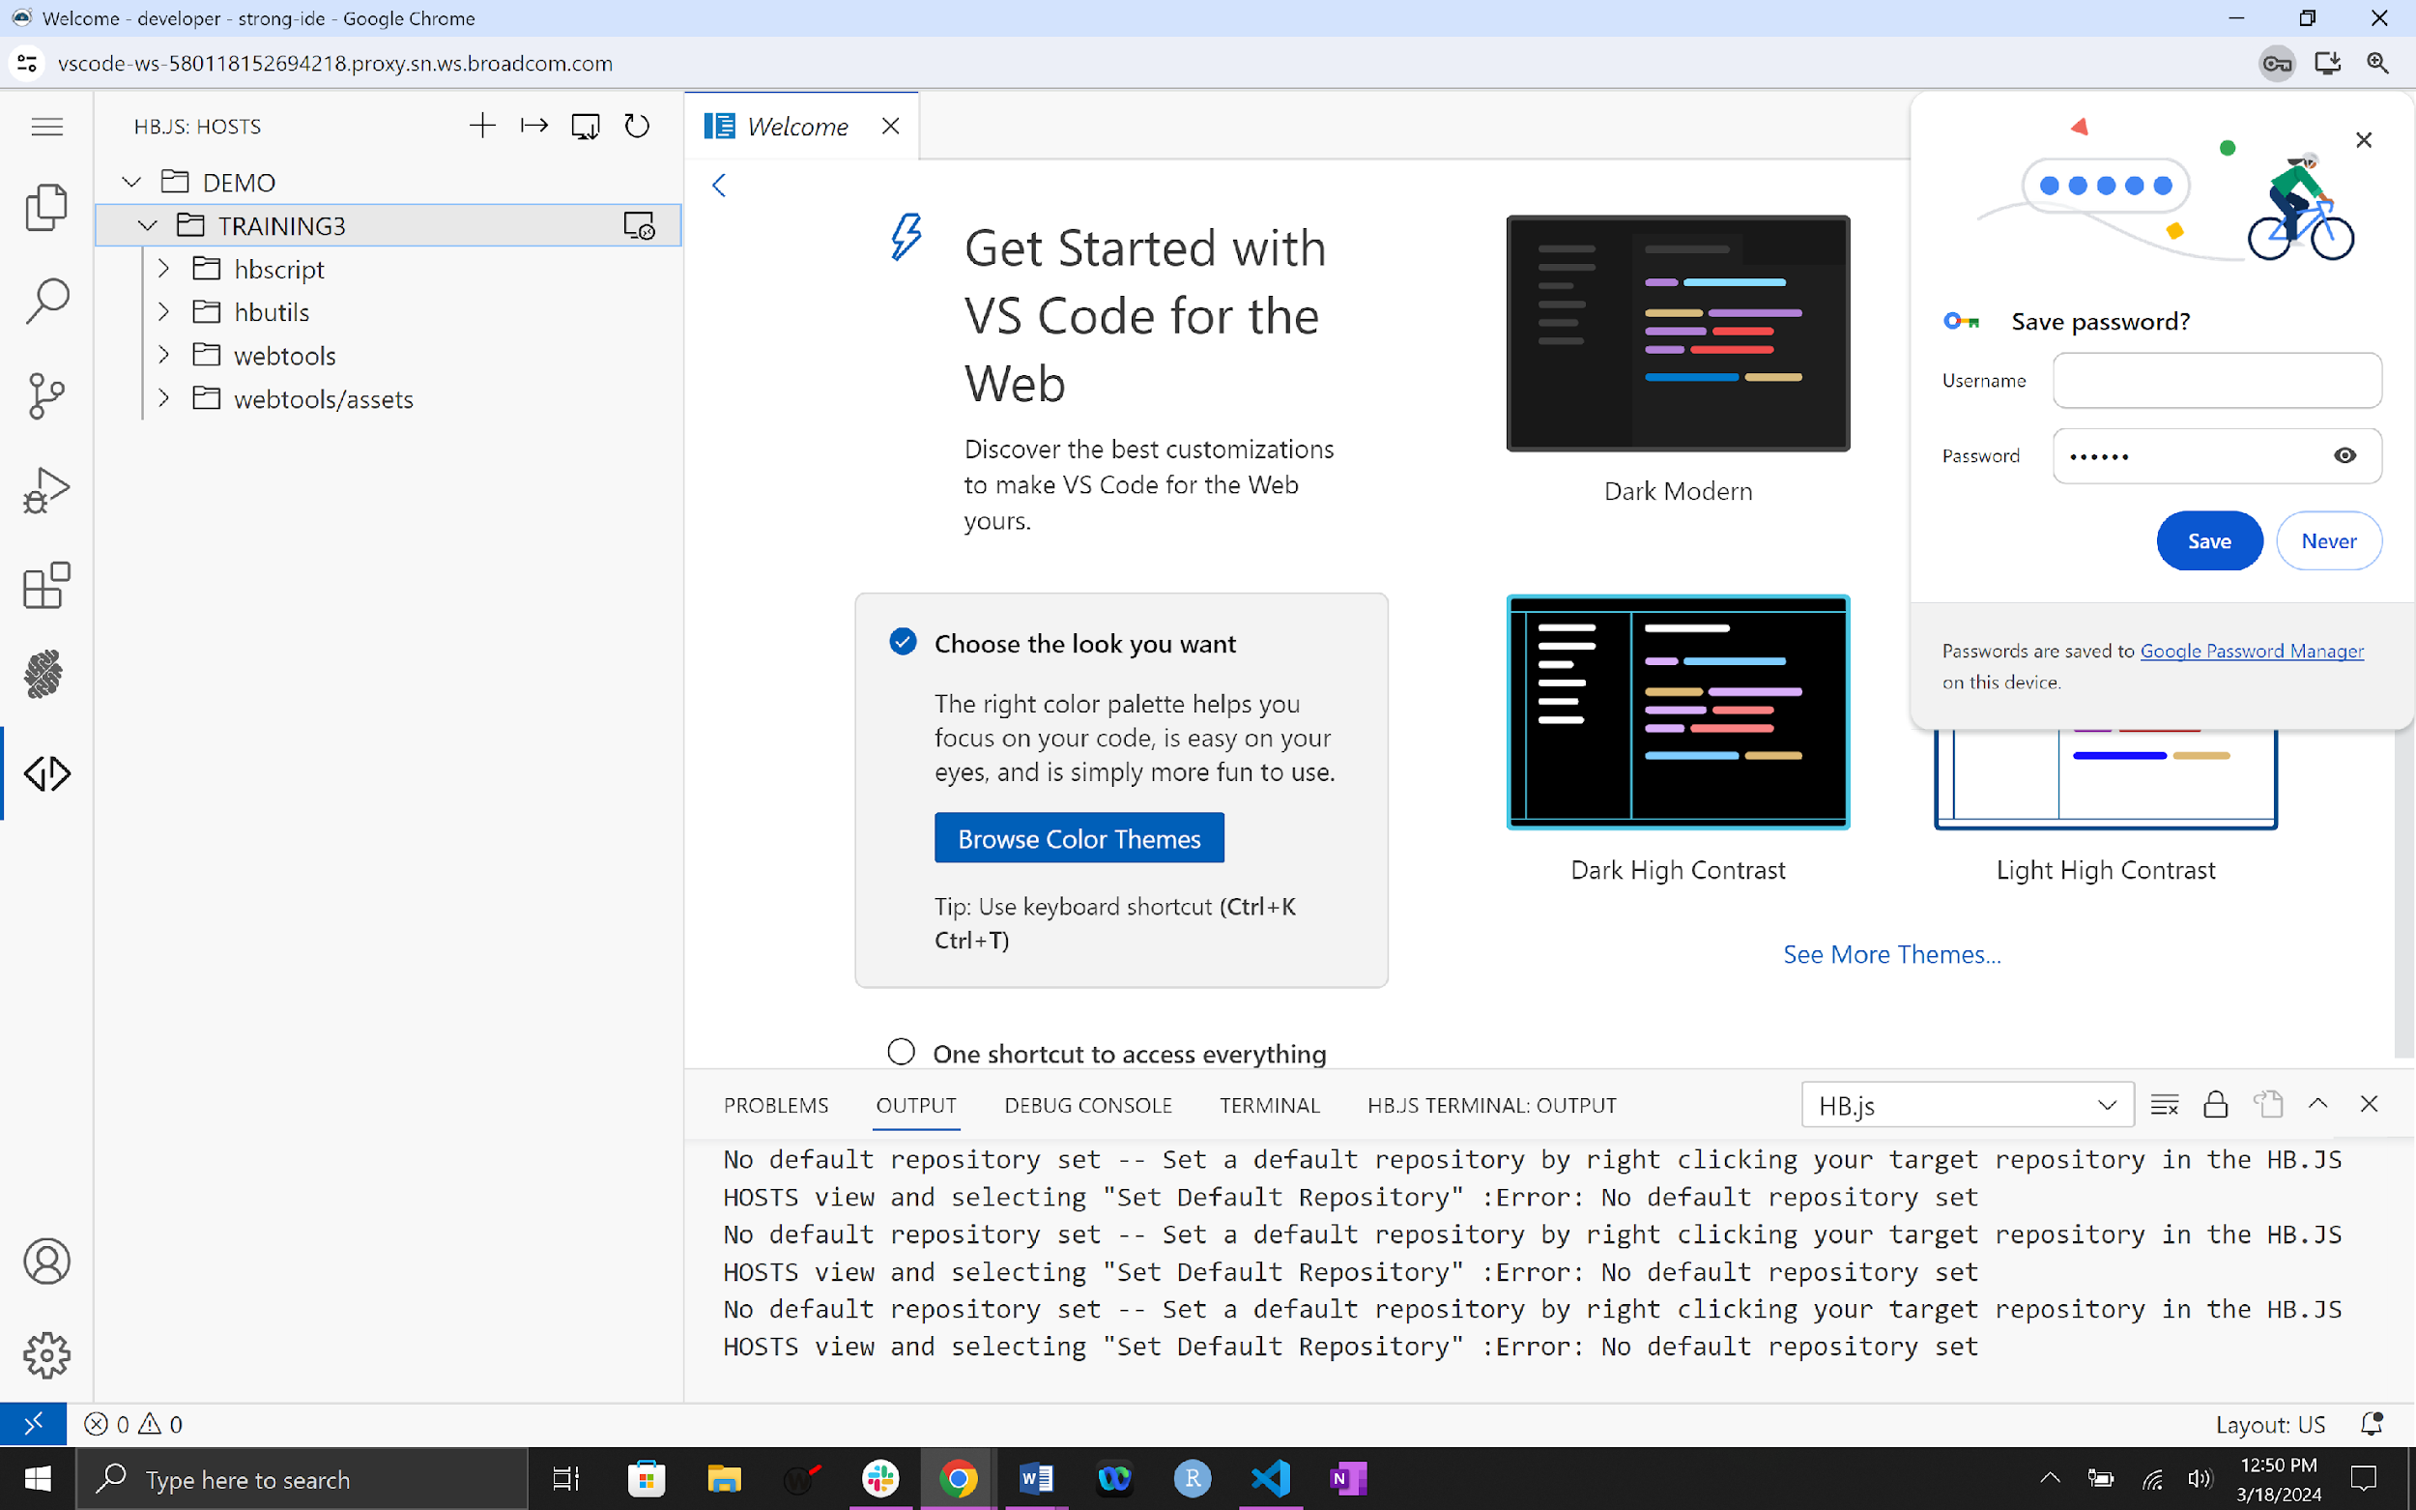

Right click the hbscript folder. Then click Set Default Repository

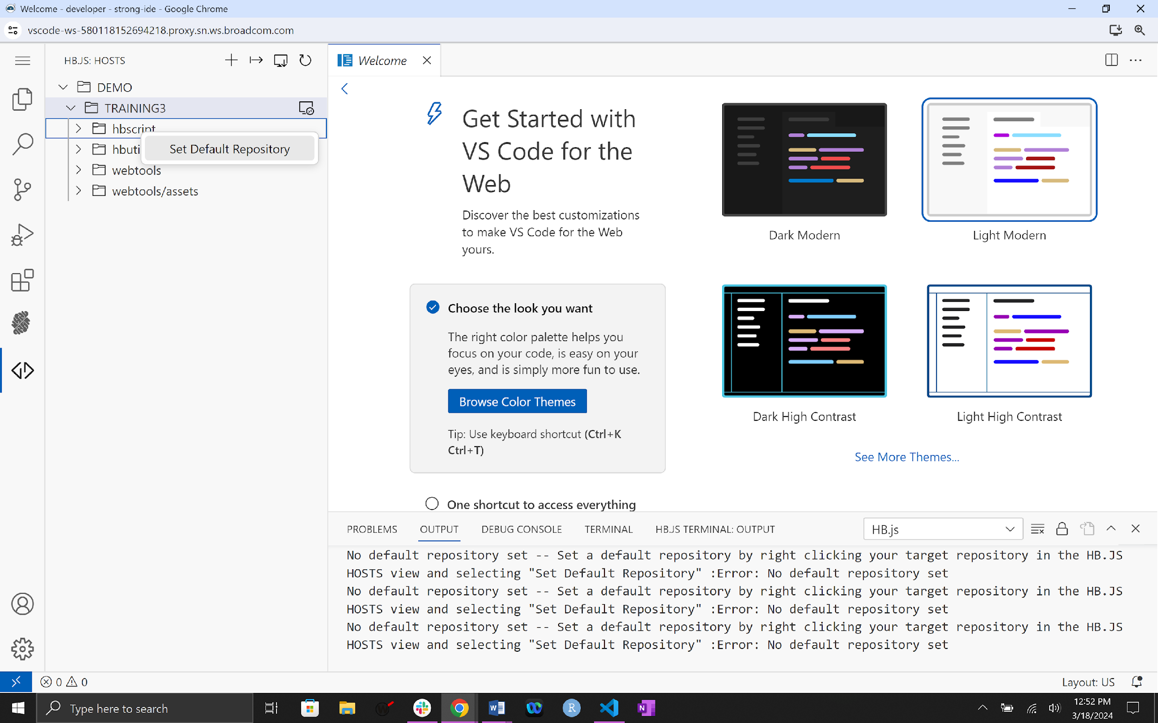

The following screen will be returned. Notice you now have a message stating, “Default Repository Set”.

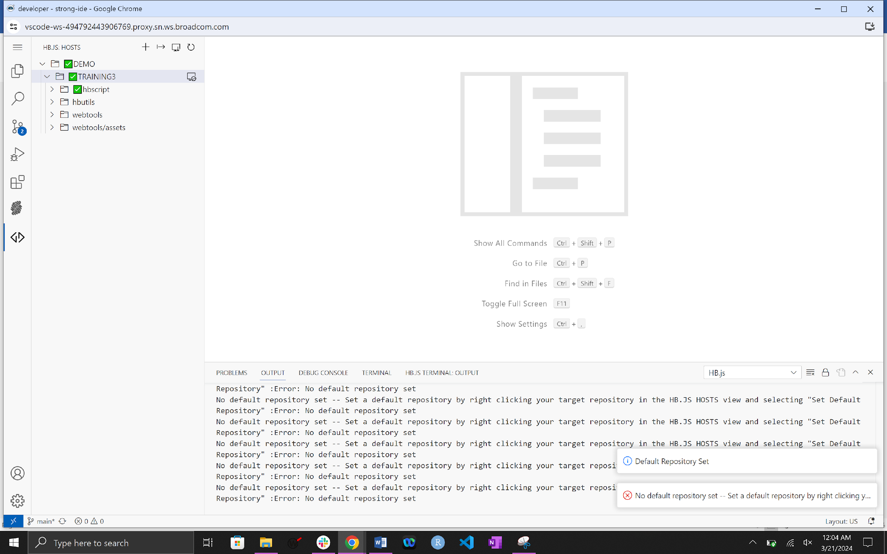

**Get exercises:**

[1] At this point you are ready to access the exercises for the workshop. Navigate to the explorer tab and expand the Walkthrough folder. The following screen is returned.

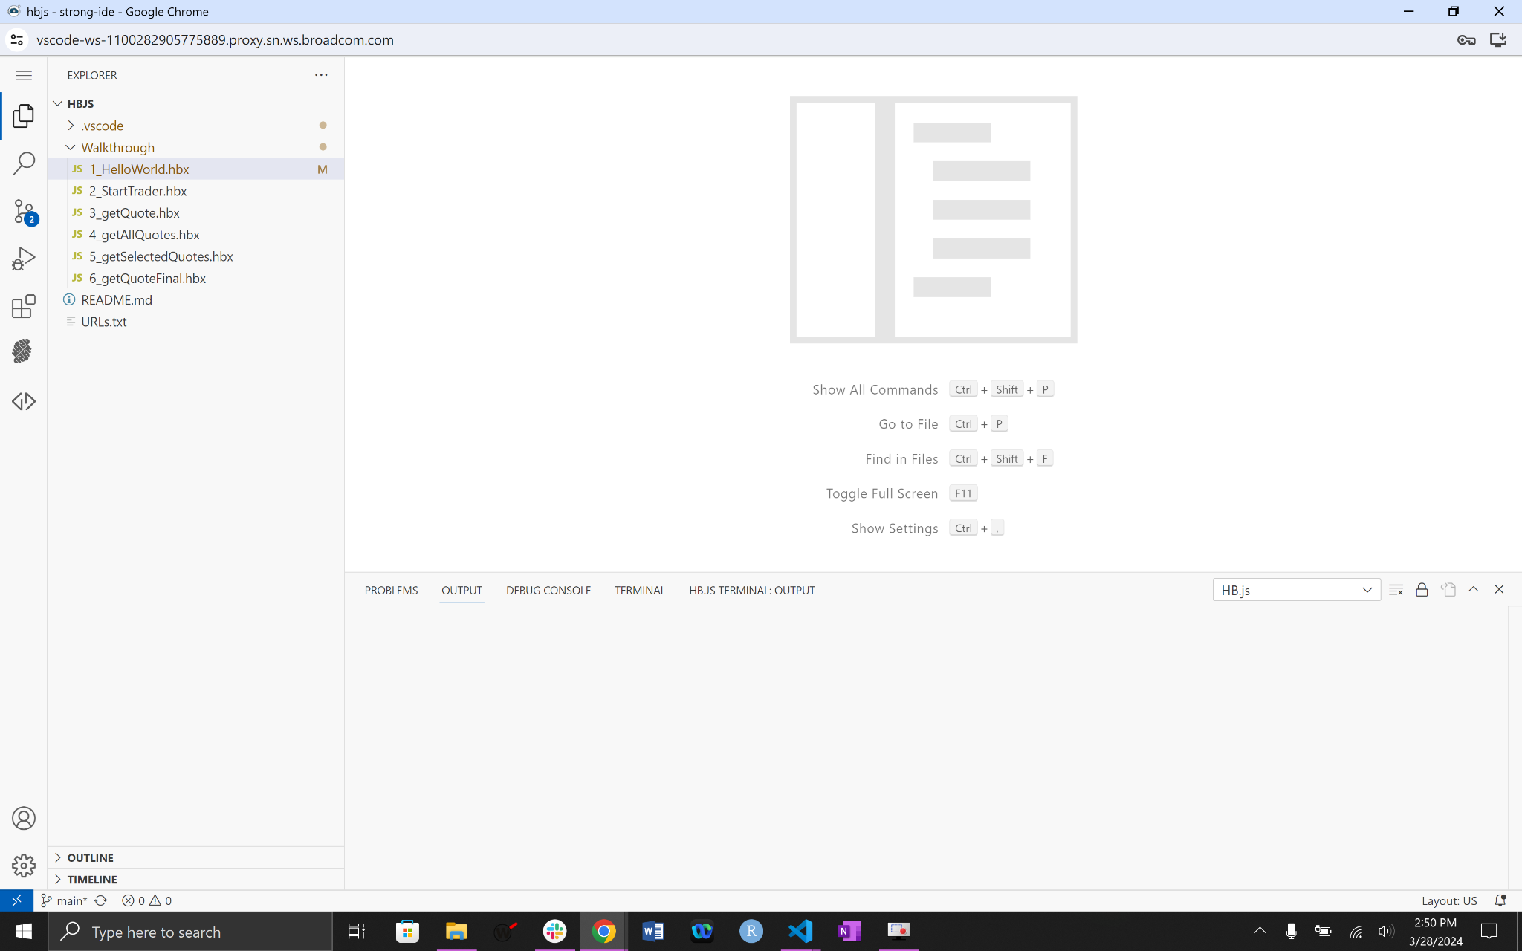

**Workshop #1**

The first workshop exercise is to change a line of Java Script. In the folder Walkthrough you will notice two files.

1-HelloWorld.hbx

2-StartTrader.hbx

Rename the 1-HelloWorld.hbx, by right clicking the file and then selecting rename.

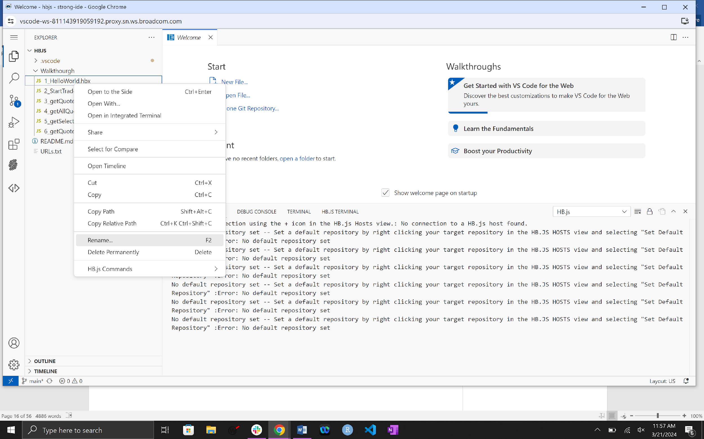

The new file name should be prefixed by your assigned userid mfwsuser## where the ## is your assigned number. So the file name should look like:

**mfwsuser##_HelloWorld.hbx**

The next step is to click on the file to open it and modify line 24:

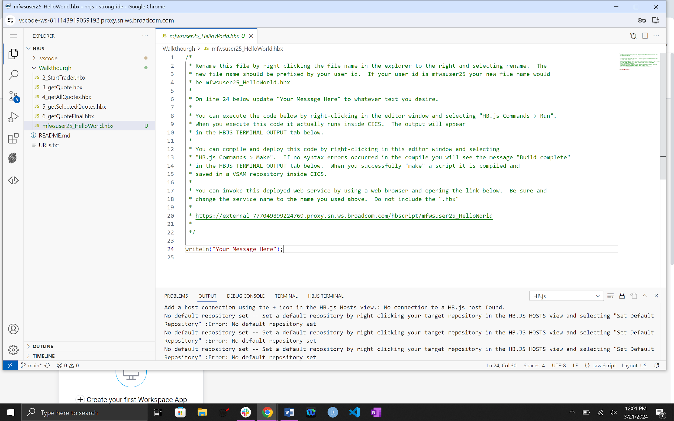

Change “Your Message Here” to the message you desire.

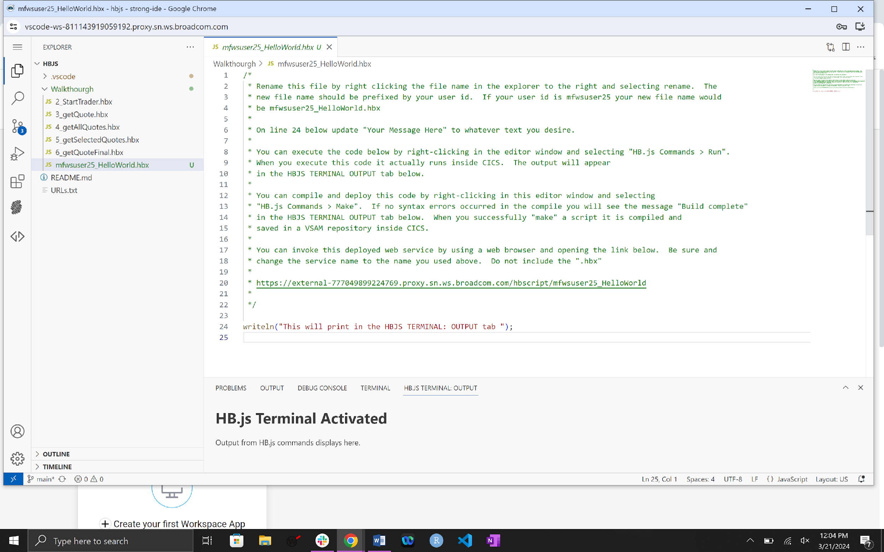

To execute the script right click anywhere inside the code and hover over HB.js Commands, notice three options:

Make – Places the script on the mainframe and compiles it. It will only put the script on the mainframe if there is a clean compile.

Put – Places the script on the mainframe

Run – executes the script

You can also use the listed hot keys if that is your preference.

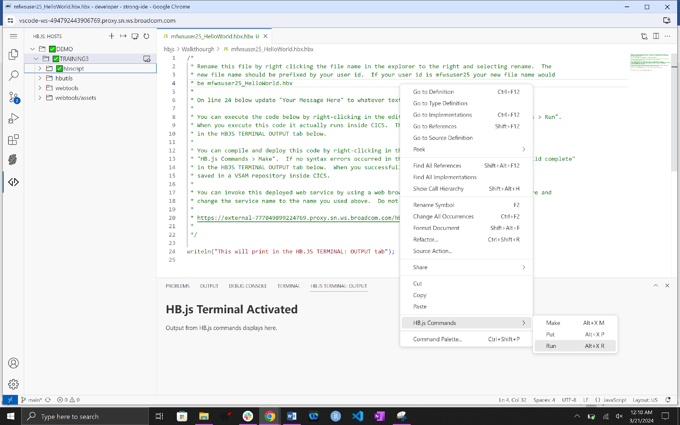

Select the HB.JS TERMINAL:OUTPUT tab and then Click HB.js Commands > Run (the tab need only be selected once per session, after that it has been activated and will open for you when output is printed to it).

When you execute the script it is actually running inside the CICS region.

See your message in the HB.JS TERMINAL:OUTPUT and the Success prompt on the bottom right.

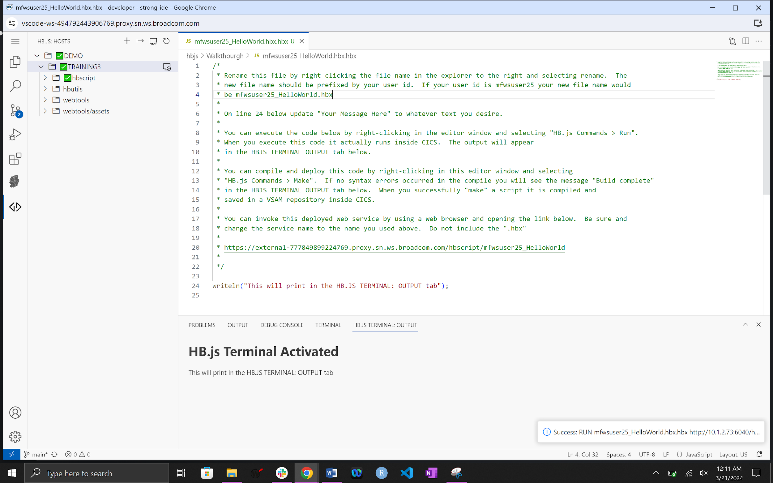

Next right click inside the code and click Make.

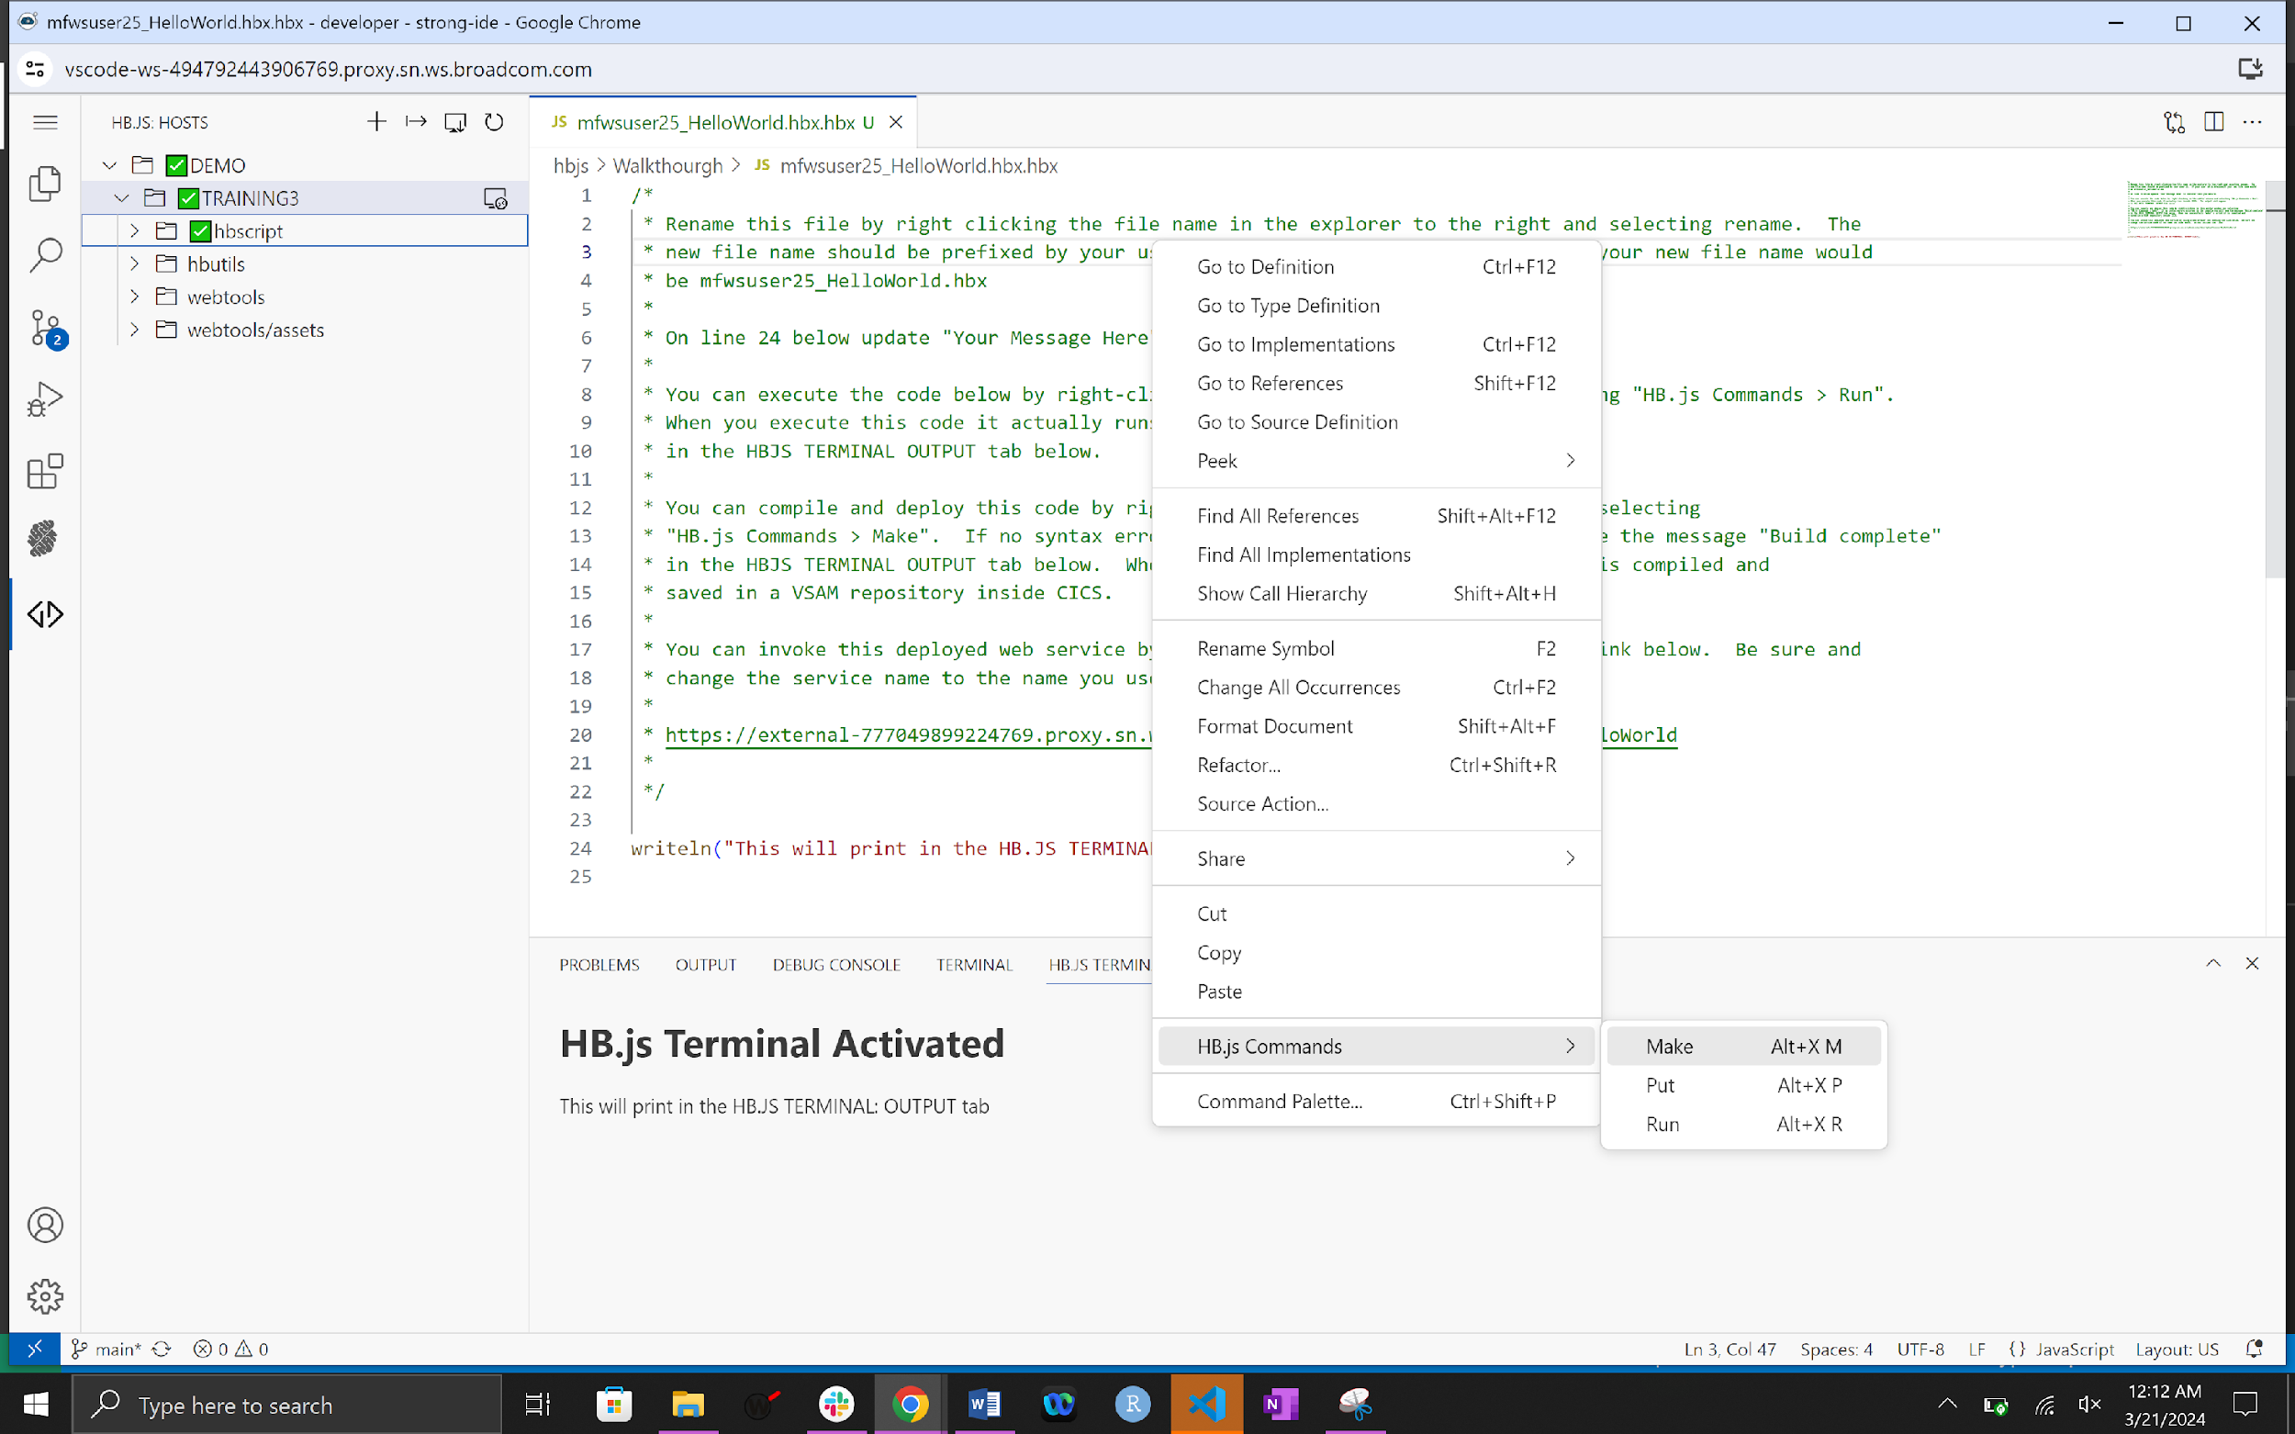

If there are no errors you will have compiled and copied the code to the mainframe. Notice the message in the HB.JS TERMINAL:OUTPUT.

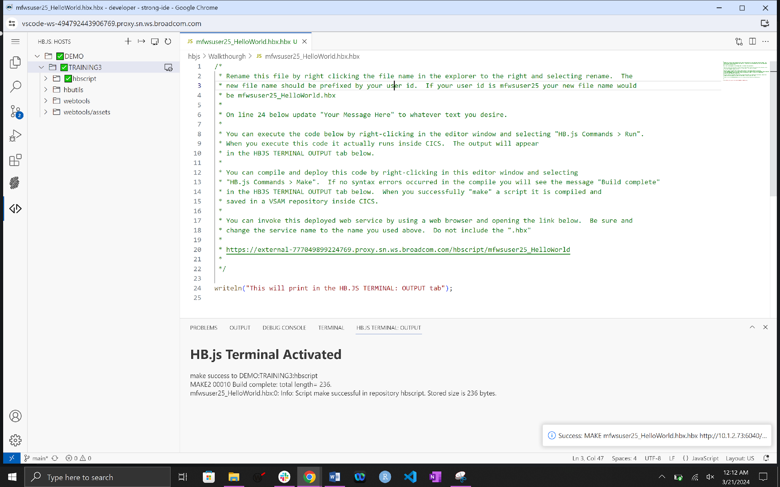

Next would be to invoke this service using a web browser and opening the following link. Note: Replace ## in the link with the User number allocated to you.

[https://external-157476462544637.proxy.sn.ws.broadcom.com/hbscript/mfwsuser##_HelloWorld](https://external-157476462544637.proxy.sn.ws.broadcom.com/hbscript/mfwsuser)

For example:

<https://external-157476462544637.proxy.sn.ws.broadcom.com/hbscript/mfwsuser25_HelloWorld>

The following screen should be returned.

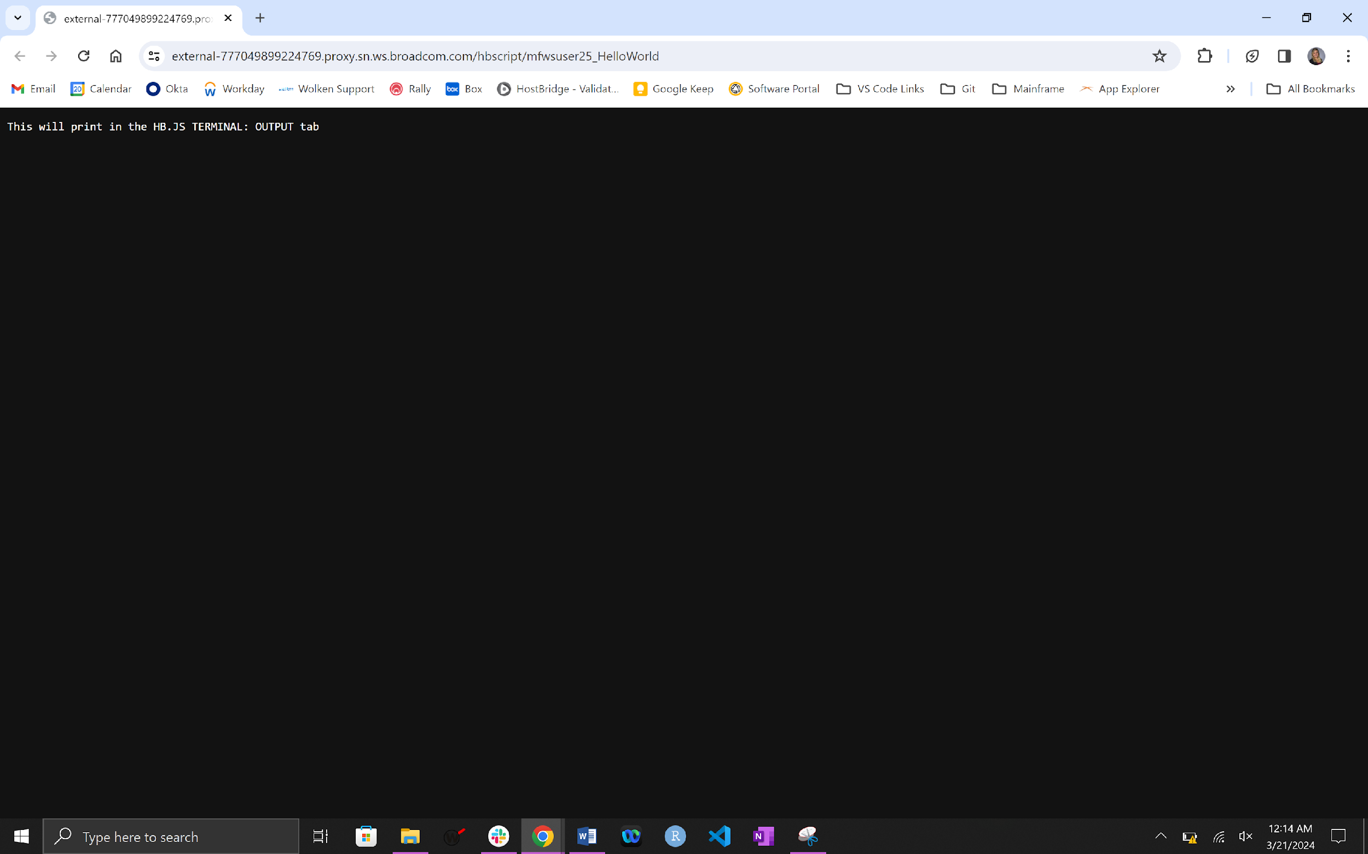

Congratulations you have completed the first exercise.

**Workshop #2**

Repeat the renaming steps in Workshop #1 on 2-StartTrader.hbx.

Once the file has been renamed we are going to use the utility Application Explorer. To use this utility open a browser and issue the following link.

[**https://external-157476462544637.proxy.sn.ws.broadcom.com/webtools/index.html**](https://external-157476462544637.proxy.sn.ws.broadcom.com/webtools/index.html)

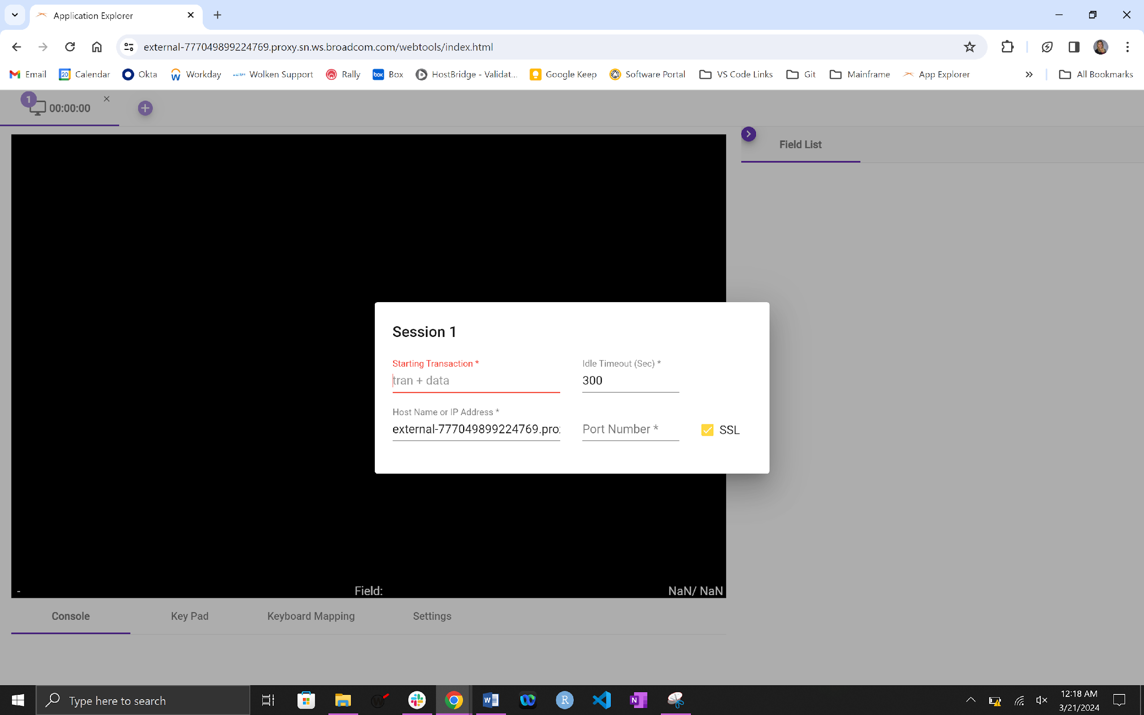

On the Starting Transaction field enter TRAD.

Press enter to navigate to the below screen.

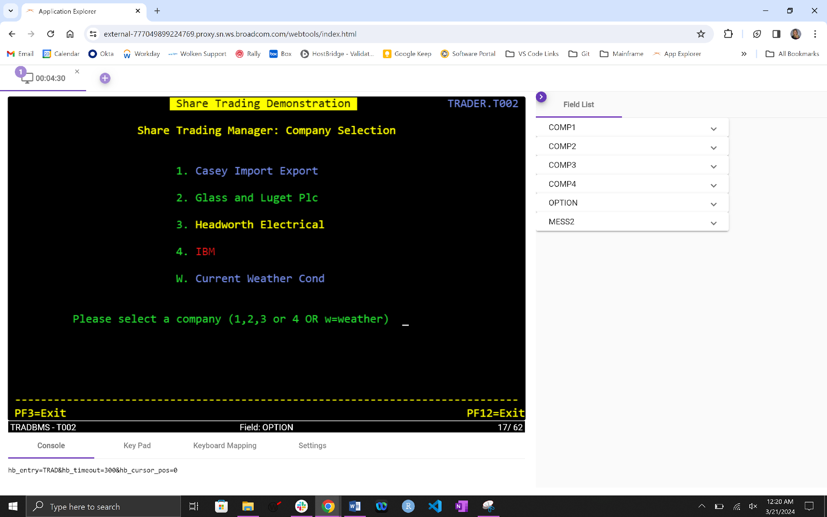

One feature HB.js has is its Code Flow capabilities. Click on the purple arrow in the circle and turn it on by clicking on the slide bar.

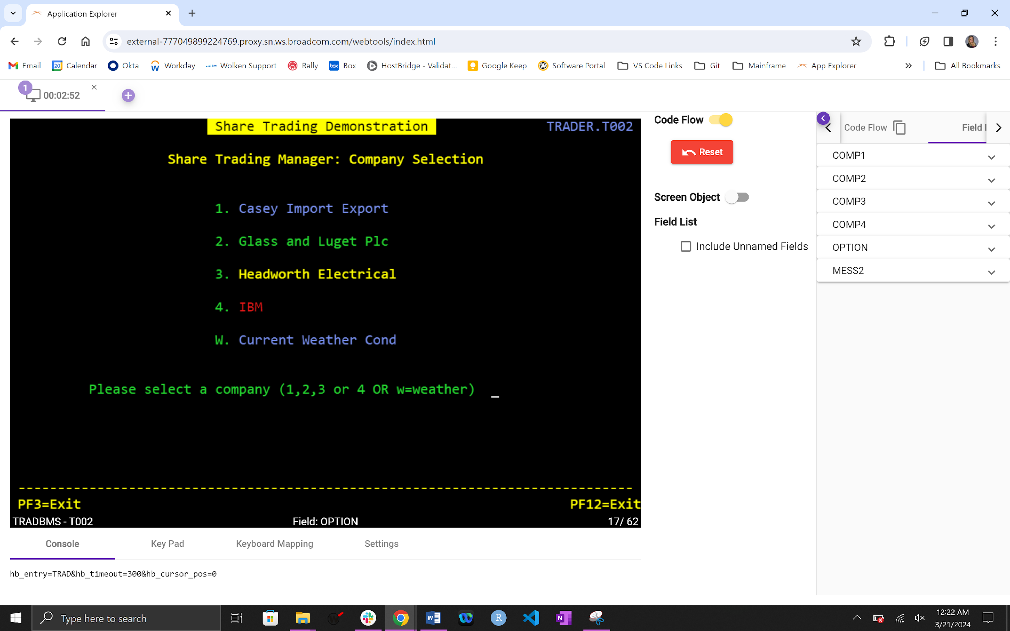

At this point you are walking through an application and recording the steps. Enter a 1 on the Please select a company field and press enter.

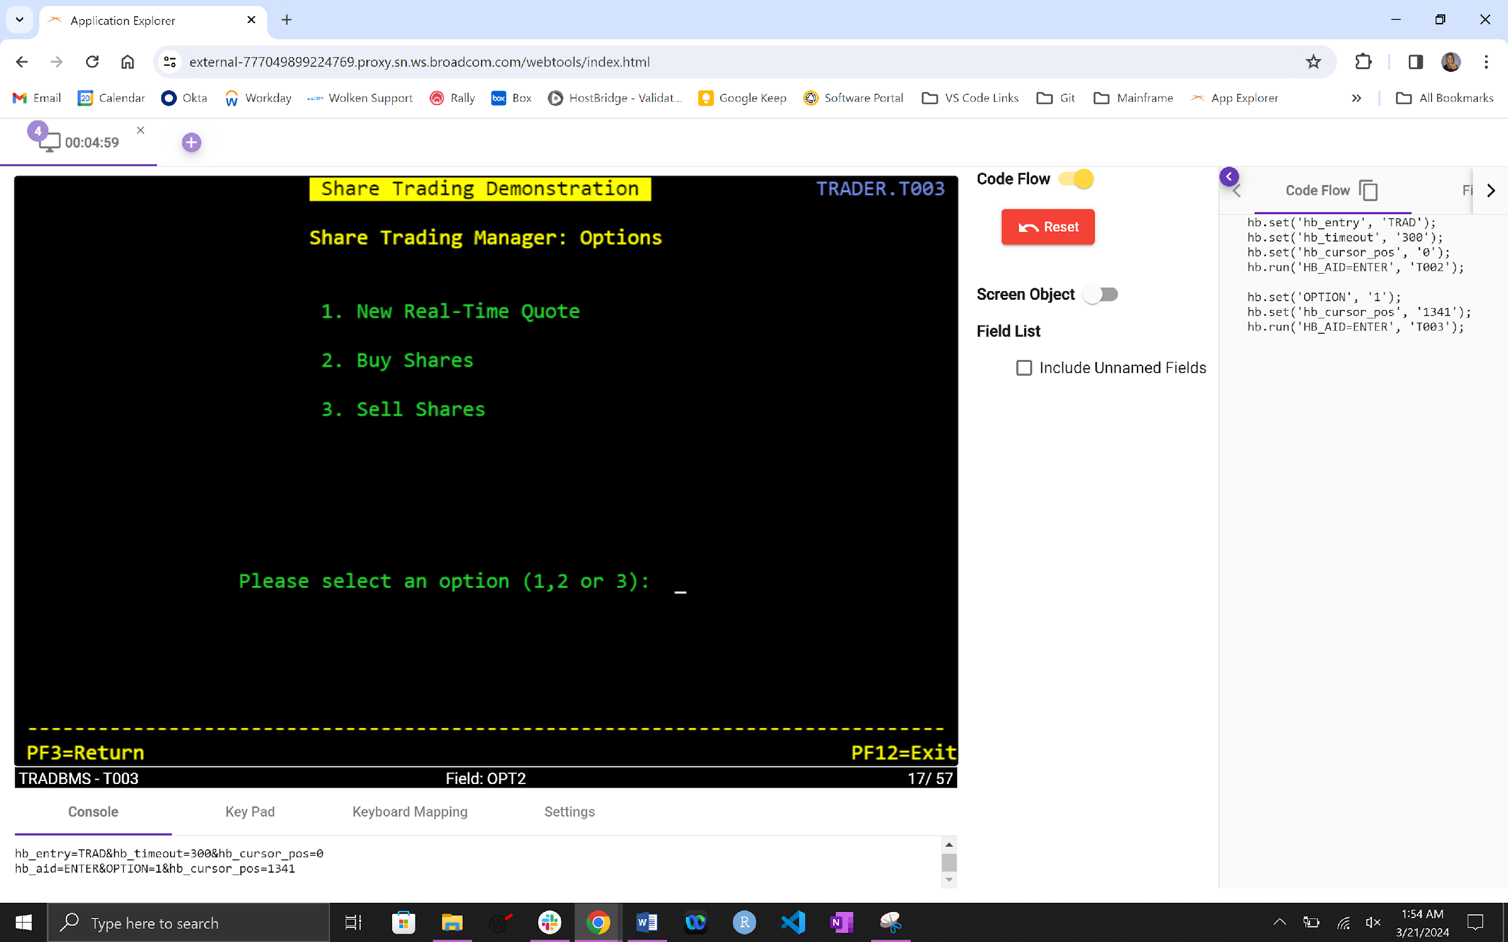

The screen changes to Share Trading Demonstration but in the Code Flow you see the HB.js commands.

Enter a 1 on the Please select an option field and press enter. See how the Code Flow has changed.

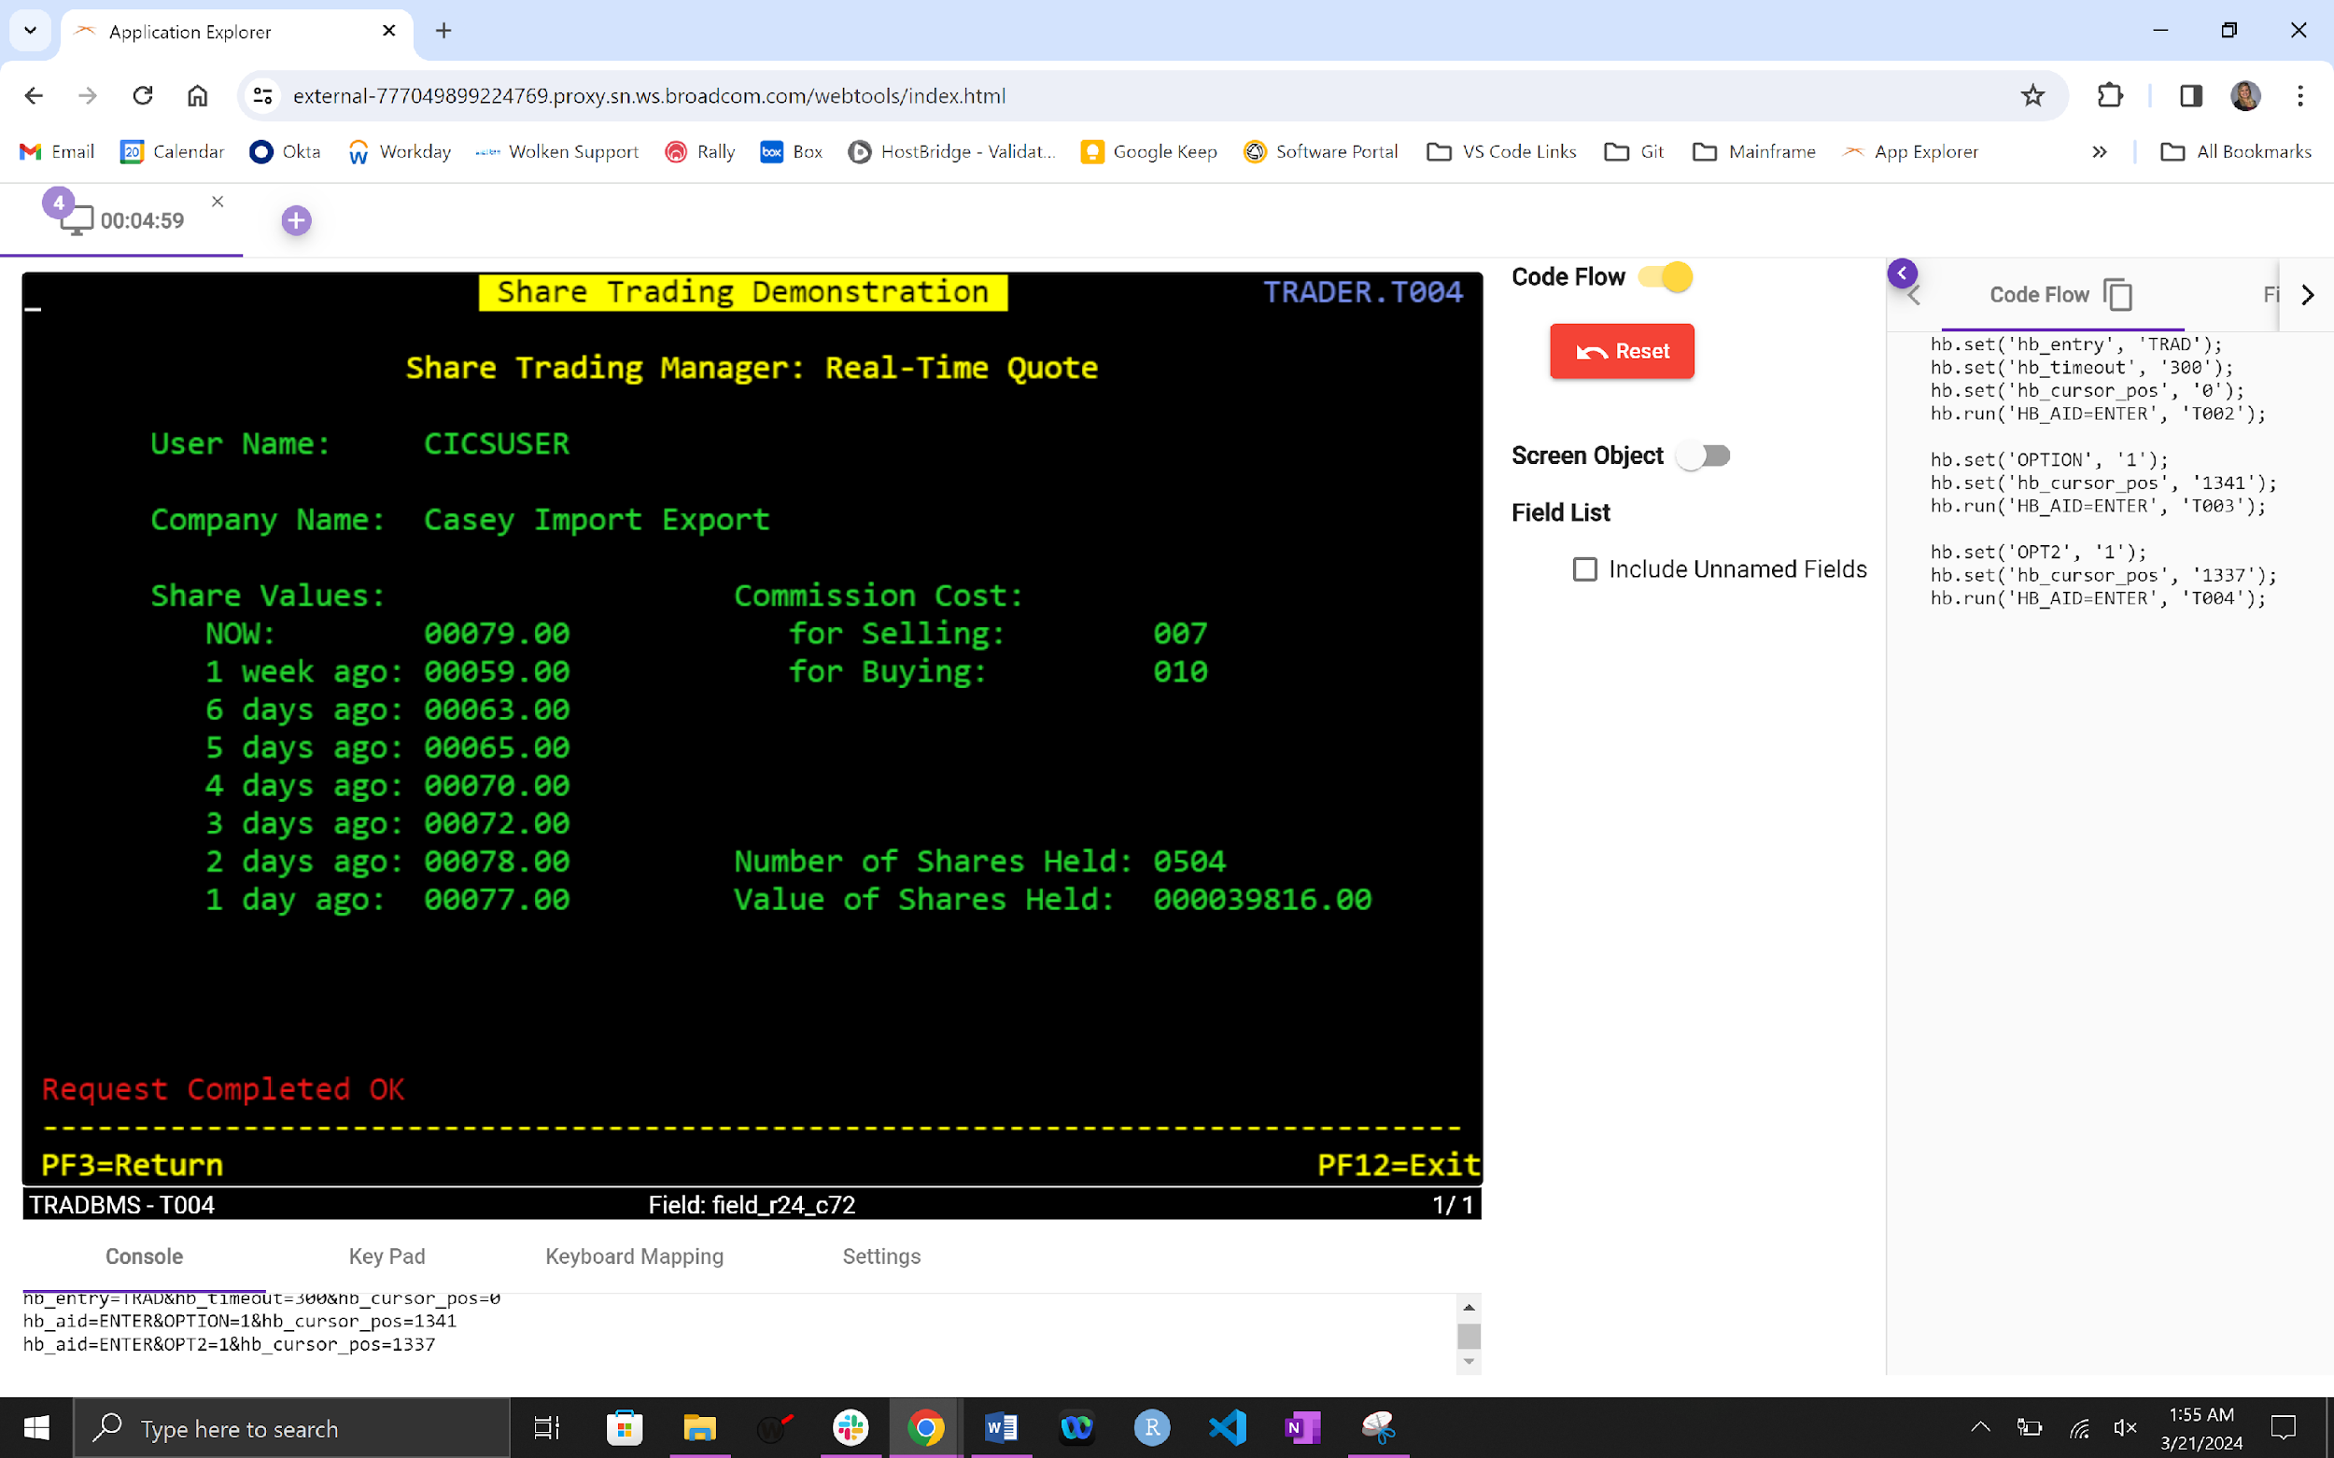

Place your cursor on the Number of Shares Held field and double click. This will add the field to the Code Flow.

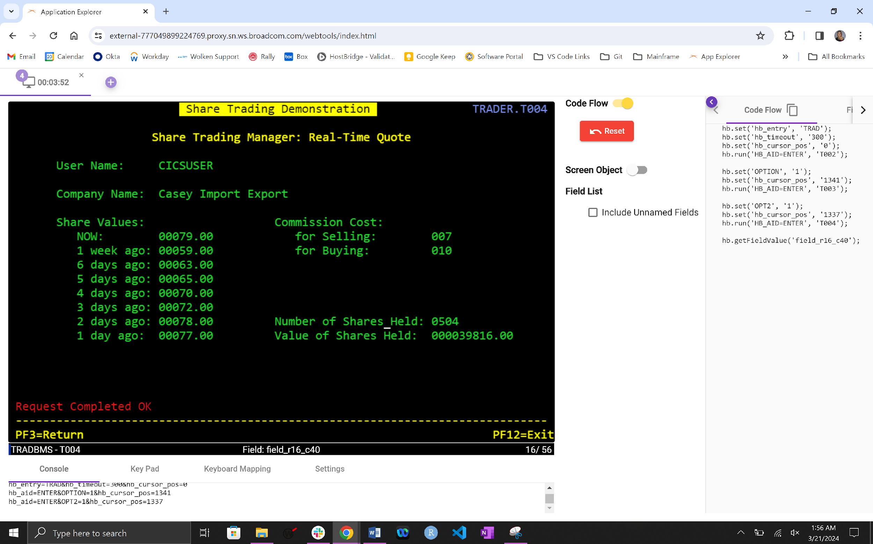

Repeat again with the Value of Shares Hold field.

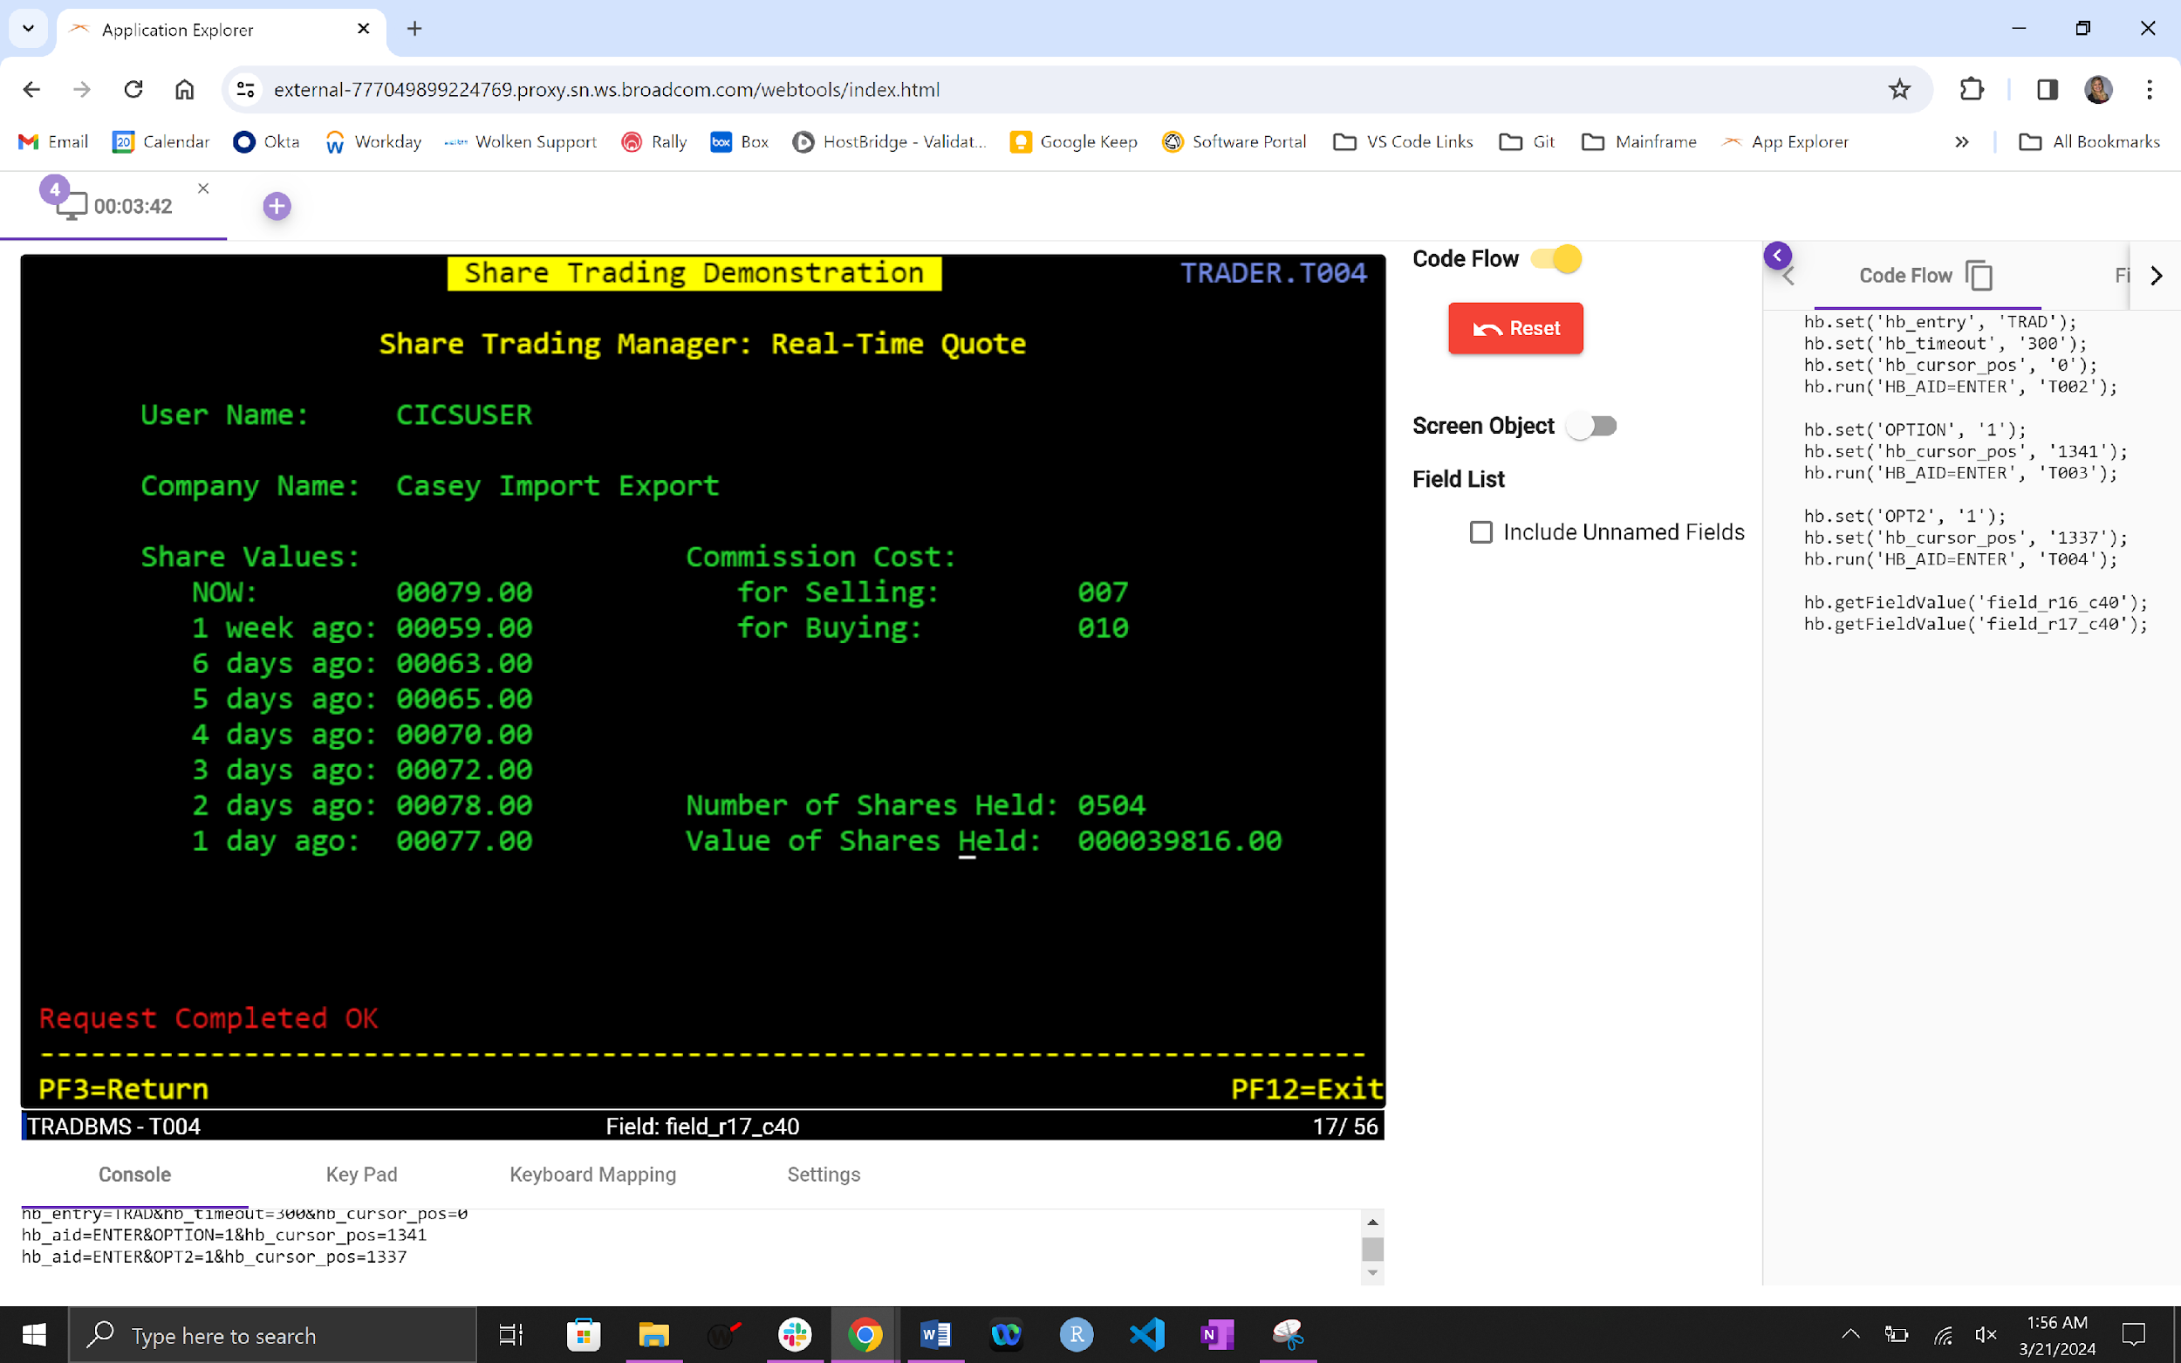

Now place your cursor on the value of the Value of Shares Held field which is 000039737 and double click. This will add the value to the Code Flow.

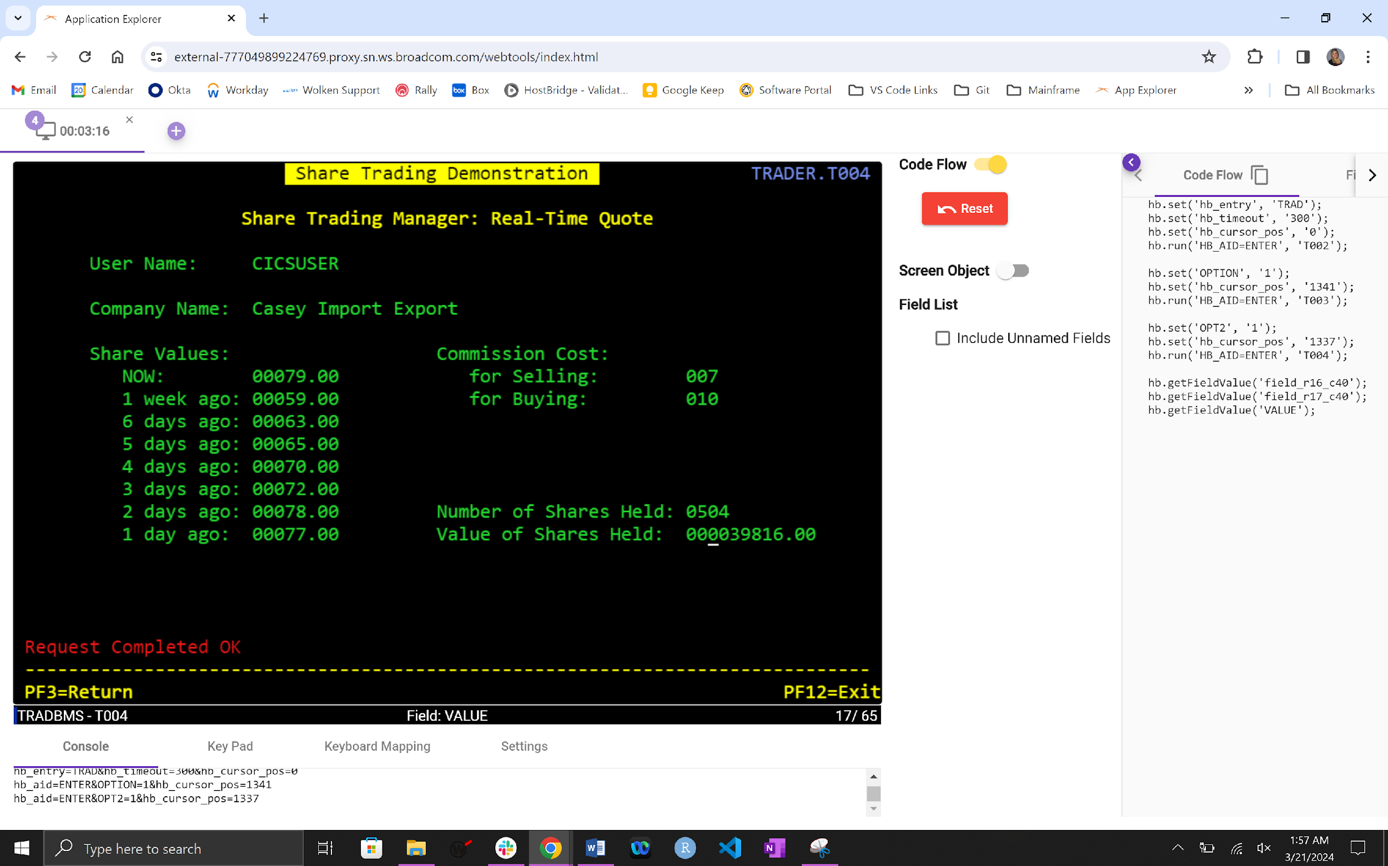

At this point HB.js has written the code for you. All you have to do is copy it and paste it into the script between the following lines:

// ------------- Paste the copied code below here

// ------------- Paste the copied code above here

So it will look like the following:

// ------------- Paste the copied code below here

hb.set('hb_entry', 'trad');

hb.set('hb_timeout', '300');

hb.set('hb_cursor_pos', '0');

hb.run('HB_AID=ENTER', 'T002');

hb.set('OPTION', '1');

hb.set('hb_cursor_pos', '1341');

hb.run('HB_AID=ENTER', 'T003');

hb.set('OPT2', '1');

hb.set('hb_cursor_pos', '1337');

hb.run('HB_AID=ENTER', 'T004');

hb.getFieldValue('field_r16_c40');

hb.getFieldValue('field_r17_c40');

hb.getFieldValue('VALUE');

// ------------- Paste the copied code above here

At this point you can right click the script and issue the HB.js Commands > Run

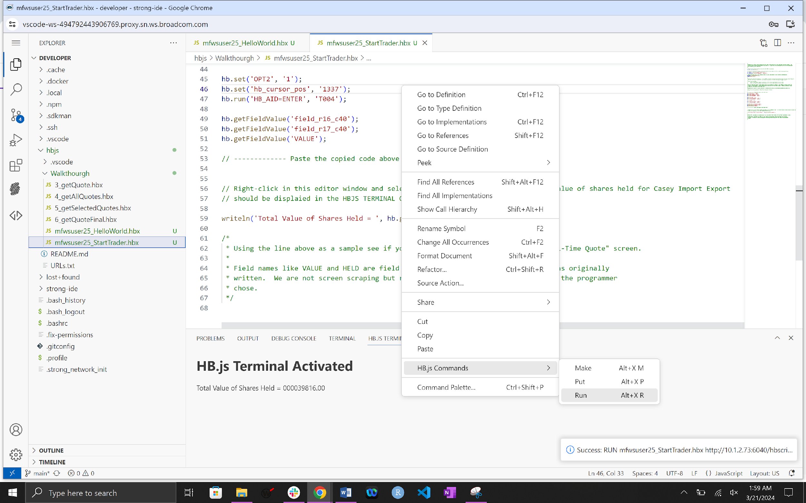

**You should see Total Value of Shares Held = 000039737.00**

Once you have completed this part of the exercise add another output field Number of Shares Held. To do this you have to go back to the Application Explorer screen and double click the value for Number of Shares Held field.

When you double click the value you will see the HB.js command added to the Code Flow.

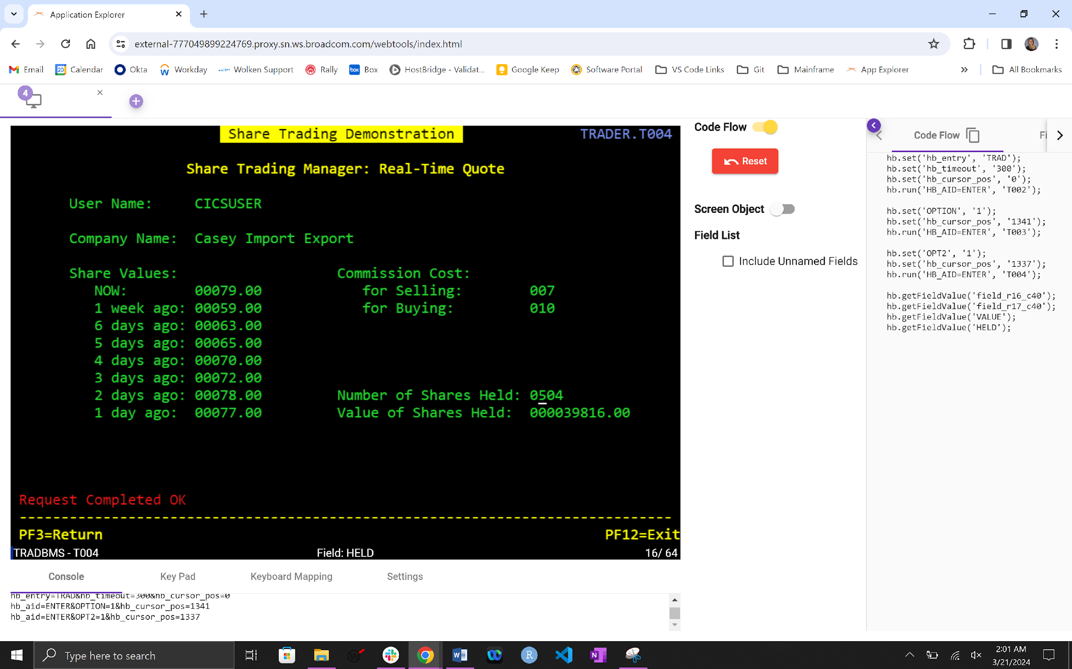

hb.getFieldValue(‘HELD);

In the script let’s add the HELD value to the output. To do this repeat line:

writeln(‘Total Value of Shares Held = ‘, hb.getFieldValue(‘VALUE’));

and change the wording to ‘Number of Shares Held’

and VALUE to HELD

When you are finished it should look like the following.

writeln(‘Total Value of Shares Held = ‘, hb.getFieldValue(‘VALUE’));

writeln(‘Number of Shares Held = ‘, hb.getFieldValue(‘HELD’));

Repeat the above instructions on running the script and notice the second line of output.

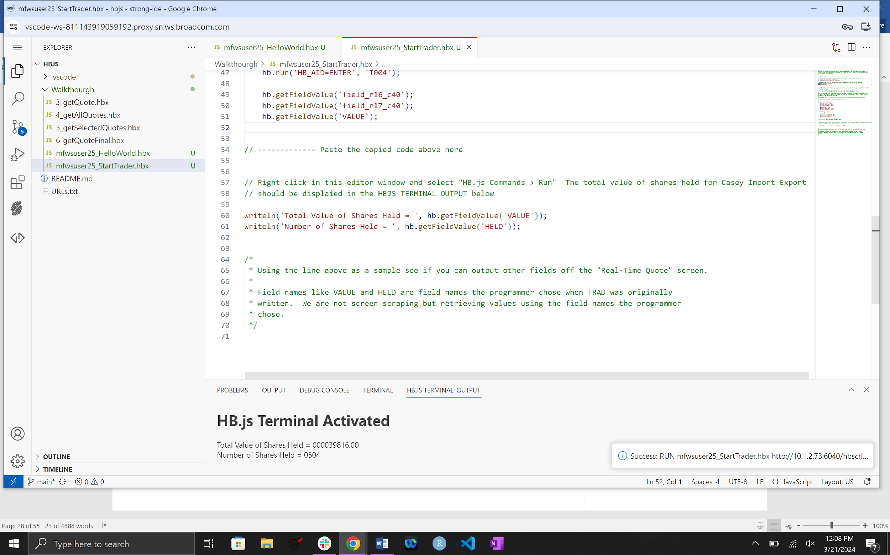

The complete script should look close to the following:

 /*

 * Rename this file by right clicking the file name in the explorer to the right and selecting rename.  The

 * new file name should be prefixed by your user id.  If your user id is mfwsuser25 your new file name would

 * be mfwsuser25_StartTrader.hbx

 */

// Create the hb object that can interact with CICS transactions

let hb = new HB.Session();

// "require" JavaScript packages with predefined utilities that we will use when creating services

let common = require('common', 'hbutils');

let debugging = require('debugging', 'hbutils');

// Using utilities out of the packages above to setup some default error checking and debugging

debugging.checkDebugControl();

common.hbRunProto();

/*

 * Using the Application Explorer, run the TRAD transaction and get the Real-Time Quote for Casey Import Export.

 * Be sure and turn on "Code Flow" by clicking the purple arrow and clicking the toggle switch.

 *

 * After starting TRAD:

 *      Select Casey Import Export by entering a "1" in the input field and press enter.

 *      Select New Real-Time Quote by entering a "1" in the input field and press enter.

 *

 * On the "Real-Time Quote" screen double click on any fields of interest, like "Number of Shares Held" and

 * "Value of Shares Held".  Be sure and click on the values not the field labels.  Double clicking on these

 * fields will add them to the "Code Flow".

 *

 * Application Explorer: https://external-157476462544637.proxy.sn.ws.broadcom.com/webtools/index.html

 *

 * Copy the code generated in "Code Flow" and paste it below

 */

// ------------- Paste the copied code below here

hb.set('hb_entry', 'trad');

    hb.set('hb_timeout', '300');

    hb.set('hb_cursor_pos', '0');

    hb.run('HB_AID=ENTER', 'T002');

    hb.set('OPTION', '1');

    hb.set('hb_cursor_pos', '1341');

    hb.run('HB_AID=ENTER', 'T003');

    hb.set('OPT2', '1');

    hb.set('hb_cursor_pos', '1337');

    hb.run('HB_AID=ENTER', 'T004');

    hb.getFieldValue('field_r16_c40');

    hb.getFieldValue('field_r17_c40');

    hb.getFieldValue('VALUE');

// ------------- Paste the copied code above here

// Right-click in this editor window and select "HB.js Commands > Run"  The total value of shares held for Casey Import Export

// should be displaied in the HBJS TERMINAL OUTPUT below

writeln('Total Value of Shares Held = ', hb.getFieldValue('VALUE'));

writeln('Number of Shares Held = ', hb.getFieldValue('HELD'));

/*

 * Using the line above as a sample see if you can output other fields off the "Real-Time Quote" screen.

 *

 * Field names like VALUE and HELD are field names the programmer chose when TRAD was originally

 * written.  We are not screen scraping but retrieving values using the field names the programmer

 * chose.

 */

Congratulations you have completed Workshop #2

**Workshop #3**

In this workshop you will have to change a script to execute the TRAD transactions twice for two companies. To do this a new HB.js utility function is added which will allow you to issue a PF3 command to back up one screen at a time.

Repeat the renaming steps in Workshop #1 on 3-getQuote.hbx.

As you review the script you will notice that starting at line 62 there is a function called getQuote and it takes companyNumber in as input. But as you walk through the code it will fail because of the missing F3 or PF3 command. Also notice how a screen name check has been added ‘T003’ and ‘T004’. So when a value is entered on screen to change screens, this check will make sure you are on the correct screen.

Follow the instructions provided in your file to make the required edits.

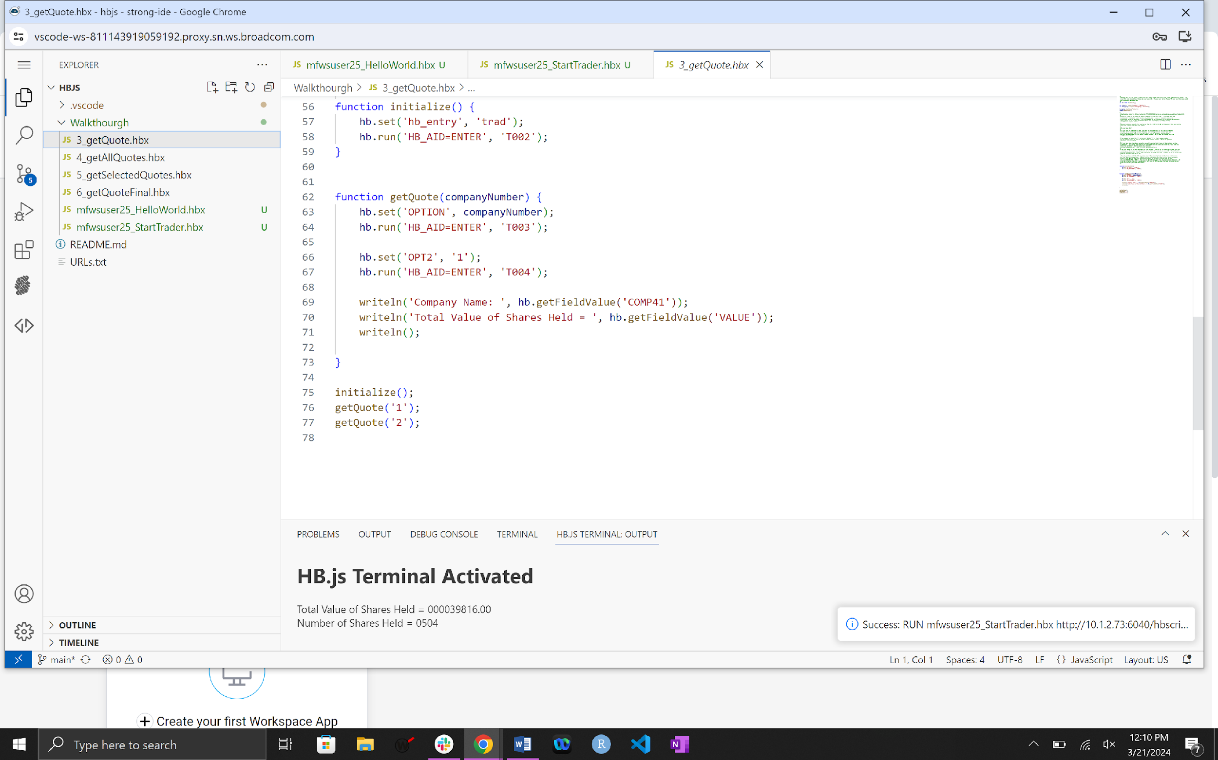

The complete script should look close to the following:

/*

 * Rename this file by right clicking the file name in the explorer to the right and selecting rename.  The

 * new file name should be prefixed by your user id.  If your user id is mfwsuser25 your new file name would

 * be mfwsuser25_getQuote.hbx

 */

let hb = new HB.Session();

let common = require('common', 'hbutils');

let debugging = require('debugging', 'hbutils');

debugging.checkDebugControl();

common.hbRunProto();

/*

 * Application Explorer: https://external-157476462544637.proxy.sn.ws.broadcom.com/webtools/index.html

 *

 * Below is close to the code you should have had in the last step.  I've taken out some

 * unnecessary statements like "hb.set('hb_cursor_pos', '1337');" because TRAD is not

 * sensitive to cursor position.  I've also wrappered the statements in a function definition.

 * This allows us to get the "Real-Time Quote" for any company by simply passing

 * a different company number.

 *

 * However when you execute the code below (try it: right click HB.js Commands > Run) you receive

 * the same company with the same values.

 *

 * Do you know why?

 *

 * If you look at the flow of TRAD, you have to navigate back to the "Select Company"

 * screen before selecting the next company.  On the Application Explorer you see

 * that means pressing the F3 or PF3 key twice.  In the getQuote function below

 * we are not backing up to the Select Company screen.  HB.js does not change the flow

 * of the transaction.

 *

 * The command to press the PF3 is hb.run('HB_AID=PF3');  That command needs

 * to be entered twice to back up to the select company screen.  Add it to getQuote

 * function now and retest.

 *

 * If you have done the above correctly you will receive Total Value of Shares Held for two

 * companies.  But notice that the hb.run you added does not look like other hb.runs, they all

 * have two parameters whereas yours only has one:

 * hb.run('HB_AID=ENTER', 'T002'); vs hb.run('HB_AID=PF3');

 *

 * The T002 above is the BMS map name for that screen.  The hb.run is checking to make sure you

 * ended up on the screen you expected to be on after the command was executed.  The statement

 * hb.run('HB_AID=ENTER', 'T002') says that after pressing the enter I expect to be on screen T002

 * and if not then throw an error.

 *

 * How do you know what the BMS map names are?  They are displayed in the lower left corner

 * of the application explorer.  Update the two statements you added with a second parameter

 * that is the BMS map name the application should be on after pressing the PF3 key.

 * hb.run('HB_AID=PF3', 'BOB');  You can get the BMS map name from the Application Explorer.  If

 * you get it wrong the error message will tell you the BMS map name that was encountered and

 * you can correct your code and retest.

 */

function initialize() {

    hb.set('hb_entry', 'trad');

    hb.run('HB_AID=ENTER', 'T002');

}

function getQuote(companyNumber) {

    hb.set('OPTION', companyNumber);

    hb.run('HB_AID=ENTER', 'T003');

    hb.set('OPT2', '1');

    hb.run('HB_AID=ENTER', 'T004');

    writeln('Company Name: ', hb.getFieldValue('COMP41'));

    writeln('Total Value of Shares Held = ', hb.getFieldValue('VALUE'));

    writeln();

**hb.run('HB_AID=PF3');**

**hb.run('HB_AID=PF3');**

}

initialize();

getQuote('1');

getQuote('2');

Congratulations, you have successfully completed the scheduled workshops. We have included an additional three workshops for you to try on your own if interested.

1.